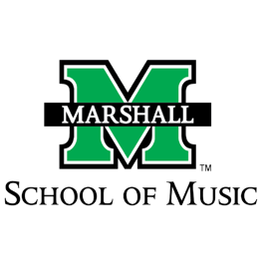
Name______________________
Class_______________________
Date_______________________

Wind Symphony Concert Worksheet 1
Livestream- http://www.marshall.edu/music/youtube
Concert Program- https://tinyurl.com/muwsprogr

A typical wind symphony is made up of 30-40 musicians. What was different about this wind symphony concert?

How many pieces were performed on the concert?

Did you recognize any of the composers? If so, which one(s)?

Which piece was your favorite? List the title and the composer and why it was your favorite.

List three things you learned from the concert program.
1)

2)

3)

How did the concert adapt the music to fit the instruments they had available?

What other observations did you about (or during) this concert?

Name______________________
Class_______________________
Date_______________________

Wind Symphony Concert Worksheet 2
Livestream- http://www.marshall.edu/music/youtube
Concert Program- https://tinyurl.com/muwsprogr

Aaron Copland was alive from 1900-1990. What major historical events were happening during his lifetime? How would that have affected his writing of American music?

Mozart’s Serenade in B-flat was written for only wind instruments. For what other genres did Mozart write? What do you think he is most known for?

Julie Giroux is a famous female band composer who has written for movies such as Star Wars, commercials like Meow Mix, and video games. Name two other female instrumental composers and what type of music they compose. Describe two reasons you like their music.

Menlo Park, 1879 was inspired by Thomas Edison’s reveal of the electric light bulb. What other major inventions shaped the way we live. Are there any other songs written about inventions?

Gordon Jacob’s piece took existing folk melodies and arranged them for an instrumental ensemble. Folk songs are radiationally passed down orally and typically tell a story. What makes folk songs good for rearranging into other forms? Name three folk songs you think would make great songs to arrange for an instrumental ensemble.

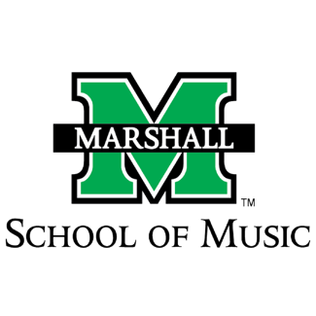

Wind Symphony Concert Written Review Worksheet
Livestream- http://www.marshall.edu/music/youtube
Concert Program- https://tinyurl.com/muwsprogr

Use this worksheet as a guide to write your review of the concert.

Opening Paragraph
- Briefly describe the event (type of music, theme, ensemble, date, time, location, purpose, etc.). Summarize the general experience but avoid listing all the compositions in this paragraph.

Body of the paper
- What about the concert experience was new or different to you? Think in terms beyond COVID-19
- What impressed you about the concert?
- Which pieces appealed to you the most? Explain what it was about the music performance that made it stand out. Be specific
- If there was a selection that you didn’t enjoy, why? Be specific
- Compare and contrast your favorite piece from the concert with your least favorite piece. Include at least three supportive statements for each position.
- Select a piece of literature you would add to the program. Identify two reasons why you chose that piece and decide where in the program it would be placed.
- Any other observations from the concert

Conclusion
- State your overall opinion of the group’s presentation of music?

Above all, make sure you review the musical elements of the performance.

Concert review style suggestions that will make your review more professional
- Avoid the use of the word “song” and instead use “piece” or “composition.” Songs have words while instrumental pieces do not.
- Name the title of a piece and put it in italics.
- Take some time to read other professional concert reviews.

