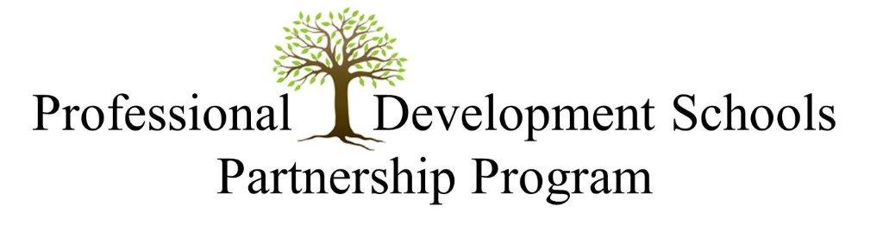
MARSHALL UNIVERSITY
COLLEGE OF EDUCATION AND PROFESSIONAL DEVELOPMENT/PDS
SCHOOL CONTRACT

My school would like to partner with Marshall University’s College of Education and Professional Development through the Professional Development Schools (PDS) Program.
My school would like to participate in the following partnership: (please check one)
____________ Professional Development School (PDS)
____________ Partner School

School Name: ___________________________________________

Principal Signature: _______________________________________
(Email and phone number): __________________________________

School Year: ____________________________________________

School Coordinator Name: _________________________________
(Email and phone number): __________________________________

Date: ___________________________________________________

