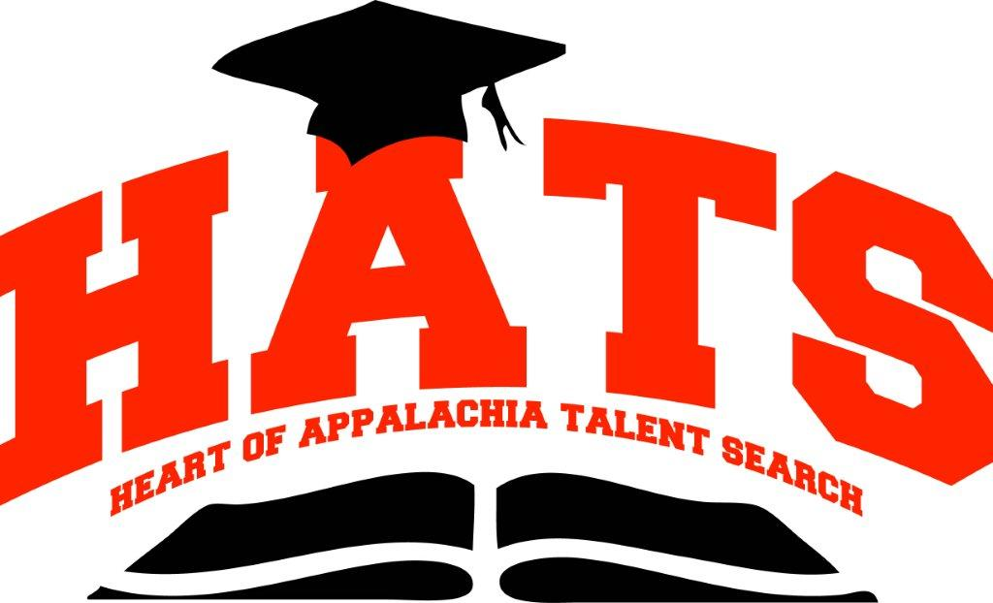
A TRiO Program

October 22, 2013

Dear Students and Parents:

With the beginning of a new school year comes the opportunity for 10th-12th grade participants in the HATS Program to take part in college campus visits to help them make the best decision for life after high school. On Saturday, November 16, 2013, the HATS Program will be visiting Alice Lloyd College in Pippa Passes, Kentucky. Alice Lloyd provides students with a unique experience of working on campus to supplement the cost of the education while taking classes. We have several alumni who are currently seeking their Bachelor’s Degree at Alice Lloyd and want to provide current participants with the opportunity to take part in a campus tour. To learn more about Alice Lloyd College, visit their website, www.alc.edu.

Registration for this event is limited to 40 students. Therefore, it is important that you complete all of the enclosed forms and return them to our office by no later than Monday, November 11, 2013. All forms should be mailed to our attention in the return envelope that is provided. Forms will be accepted on a first-come, first-serve basis. Therefore, we will not accept faxed or hand-delivered information. Please do not assume that you have been accepted to attend the campus visit until you receive a call from the HATS Program.
We take great pride in providing you with a safe, enjoyable experience that will leave a lasting impression. If you have any questions regarding this event, please feel free to contact our office at (304) 696-2941 or via e-mail at zornes@marshall.edu.

Sincerely,

Scott Robertson, Counselor
Heart of Appalachia Talent Search Program

Enclosure(s)
Travel Release, Dress Code & Code of Conduct, Tentative Schedule
Heart of Appalachia Talent Search Program
212 Gullickson Hall ◆ One John Marshall Drive ◆ Huntington ◆ West Virginia ◆ 25755-2195-104
Tel: 304-696-2941 Fax: 304-696-3271

