Journey to the “I”: An Autoethnographic Reflection of My Path Through the Doctoral Program

Julie Midkiff

Reflection Paper submitted for
Residency Requirements
at Marshall University
in partial fulfillment of the requirements
for the degree of

Doctor of Education
in
Curriculum and Instruction

Committee Chair: L. Eric Lassiter, Ph.D.
Elizabeth Campbell, Ph.D.
Lisa A. Heaton, Ph.D.
Shelia Chipley, Ed.D

South Charleston, West Virginia
2018

Table of Contents
The Beginning: Two Reflections 1
Unexpected Experiences in Employment: Underpinnings of Where I Am Today 3
“Its My Turn” Reflections Upon Being A Visual Arts Teacher 4
Finding My Footing: Fall Semester 2016 6
A Foothold Found: Spring Semester 2017 7
Summer 2017: “I” Found my Footing 9
Two Hits and a Miss: Reflections Upon the Fall 2017 Semester 13
Spring 2018: Confidence Regained and the Journey to the “I” Continued 20
“I” Hit the Ground Running: Summer 2018 Semester 23
Fall Semester 2018: Along Came a Spider and Other Reflections 25
The Journey Continued: Where “I” Will Go from Here 27
Appendix A: Abstract for CI 704 Research Project 32
Appendix B: IRB Approved Informed Consent for CI 704 Research Project 33
Appendix C: Cover Design for the 2017 Doctoral Seminar Booklet 34
Appendix D: Planning Committee Documentation for 2017 Doctoral Seminar Booklet Page 35
Appendix E: CI 701 Curricular Theory Paper 36
Appendix F: CI 701 Curricular Theory Paper Introduction………………………………………………37
Appendix G: CIEC 700: Technology and Curriculum FlipGrid Development……………………..38
Appendix H: Infographic of Tiger Tools for Student Digital Product Creation and Integration ……………………………………………………………………………………………………………………………………39
Appendix I: Infographic of Tiger Tools for Teacher Digital Product Creation and Integration 40
Appendix J: EDF 725 Advanced Qualitative Methods Elk River Chemical Spill Mini Ethnography 41
Appendix K: Co-Presenter at the 2018 Appalachian Studies 42
Appendix L: Co-Presenter at the 2018 Appalachian Studies Association Conference (Photo Collage Evidence)…………………………………………………………………………………………………………..43
Appendix M: Co-Presenter at the 2018 Southeastern Association of Vertebrate Paleontology ……………………………………………………………………………………………………………………………………..44
Appendix N: Co-Presenter at the Southeastern Association of Vertebrate Palentology (Photo Collage Evidence) 45
Appendix O: Summer 2018 Co-Teaching with Dr. Lassiter in EDF 625 (Qualitative Research in Education) 46
Appendix P: CULS 600 "Autoethnography on a Page" (Front Side)…………………………………..47
Appendix Q: CULS 600 “Autoethnography on a Page” (Back Side) 48
Appendix R: Cover design for the 2018 Doctoral Seminar Booklet 49
Appendix S: Planning Committee Documentation for 2018 Doctoral Seminar Booklet Page
50
Appendix T: 2018 NEA Foundation Global Fellows Book Publication (Cover) 51
Appendix U: 2018 NEA Foundation Global Fellows Book Publication (Kindergarten Lesson Plan 52

Journey to the “I”: An Autoethnographic Reflection of My Path Through the Doctoral Program

The Beginning: Two Reflections

From the time I walked into my seventh grade English class, I knew I wanted to become a teacher. Vee Browning was six feet tall, thin, and a bundle of energy. She would sit at her podium at the beginning of class, take attendance, and then pop out of her seat, onto her grammatically correct stage and transform the forms of be, nouns, pronouns, verbs, and adverbs from parts of speech and sentences to be practiced into a living, breathing, and practical writing experience. My elementary teachers had treated grammar as the subject that had to be taught in a perfect thirty-minute block, by the textbook, and included dragging students through the English Language Arts curriculum. These teachers, in no way, compared to the energy and excitement Mrs. Browning brought to her content area in a dimly lit room on the second floor Annex building of Beckley Junior High School. And, no one dared to interrupt her performance except, occasionally, the creaky wooden floor.
Energy, experiences, and opportunities have guided me to this point of my teaching career. I declared my major in education in the fall of 1998 at Concord University as an English Education major. By the fall of 1999, I was an Art Education major. By Fall of 2000, I was double majoring in Art Education, Graphic Design, and had decided that I could add another semester and add a studio crafts major to the list. These decisions and opportunities were guided by my advisor and life-long mentor, Dr. Sheila Chipley after a brief conversation after Crafts I class one day. She asked, “have you ever thought about being an art teacher, I think you have what it takes.” My answer, “no, I am English education, I just like art and making things.” “Well, think about it….” she said. And, I did just that. I thought about it, I talked it over with my sister on the commute home, and I had what I knew would be a tough conversation with my mom. My mom was less than thrilled that I was going to become “an art major” but said that as long as I had a backup plan since employment might be difficult in the arts. She had a legitimate concern with her worry about employment in the Arts, and by the next semester, I became a graphic design major as the backup plan.
During my time at Concord, I also served as a work study student for Dr. Chipley. I observed students coming by her office for help and guidance on projects, experienced her advising students in both education and art majors, assisted her with using new technology, and learned the importance of writing grants to attend workshops, art experiences, and to purchase supplies and equipment. When I wanted to learn basic jewelry making and silversmithing, it was Dr. Chipley that advised me to apply for a scholarship at Arrowmont School of Arts and Crafts and take a class. Once again, I found an educator that was driven, selfless in sharing her advice and experiences and invested time and energy into the interests of her students. She was invested in creating not only teachers who were proficient in teaching art, but art teachers who could go into the classroom and make art education happen for students no matter the classroom set up or teaching arrangement. During and after my years at Concord as an art major, it was Dr. Chipley that planted the idea of me being able to enroll in a doctoral program one day, an idea that took quite a few years to harvest, and took some years and experiences to nurture that seed into growing.

Unexpected Experiences in Employment: Underpinnings of Where I Am Today
After my undergraduate graduation, I watched the occasional art education opening be filled by teachers who had more years of seniority than me. Many of these art teachers gained their years of experience in another content area and were waiting “for their turn” in the art classroom. Meanwhile, I became an itinerant art teacher for two short term programs for Raleigh County Schools for a few days each week and substituted on the remaining days. With the short-term art programs coming to the end, I had few options in art education, but many substitute opportunities at the Alternative Education Center in Sophia, West Virginia.
While “waiting for my turn” for an art job at any programmatic level, I applied for the special education position in English Language Arts and Social Studies, two fields that I felt that I could teach out of certification at the Alternative Center. But, an applicant, who had only completed two master’s level classes in special education without an undergraduate teaching degree, was hired for the position. Annoyed, but determined, I applied and was hired in a similar special education position in Science and Mathematics later in the year. Although the students at the Alternative Education Center had behavioral and academic challenges and I was learning to navigate the unfamiliar course of the legality of writing an Individualized Education Plan, I was employed, in the classroom and learned a lot in my first year of teaching. I enrolled in my first two master’s courses in Special Education at Marshall University in Spring of 2005, continued with classes through Summer 2006, and by the time I interviewed at Bradley Elementary, I had the choice of accepting either the art position or the special education position. I chose the art position, without regret, but finished my master’s degree in Special Education during my first year as an Art teacher.

“Its My Turn” Reflections Upon Being A Visual Arts Teacher
During my interview to become the Art teacher at Bradley Elementary, the principal who hired me asked “How long would you be willing to stay in this position?” While I thought this was an odd question, the principal mentioned she thought the teacher turnover in the position was due to the job being “art on a cart.” “Art on a cart” referred to the Art teacher traveling from classroom to classroom with a desk and limited storage space in a corner of the building. On the tour of the school, she described the construction of the new early learning wing that was being built, and as a result of this new construction and within a year, I would be moving into a newly remodeled art classroom. The principal said, “if you can hang in there a year, you will be able to move into a classroom, make it your own, and it will be easier to stay.”
And stay I did. My first year at Bradley Elementary, I was always on the move. I had one year to transform a program while I was chasing the daily art schedule and pushing an “art cart” down the hallway. There were problems with traveling with wet art media, where to dry and store paintings, and walking into twenty-one different behavior management systems, but there were also opportunities to change the program. I chose to create lessons that were artist centered, art history based, and resulted in multi-day projects that required students to use more than one type of media.
It was also the beginning of changing the mindset towards the arts in our school. Once the principal saw the art products students were creating from the newly evolved art program and some of the obstacles we encountered with our students being able to participate in county sponsored art exhibitions, together, we discussed a new plan to celebrate the arts, both visual and musical, in our school. We decided that our school art exhibition and guitar performance would be combined together, “on the same night, it could be a Night of the Arts.” And 14 years later and by the same name, “Night of the Arts” is our annual musical performance and art exhibition where we share with our community the visual and musical arts that are the products of our programs.
My art classroom at Bradley Elementary has been the setting for multiple educational experiences. It has been the place of fieldwork for gaining experiences in building an art program, working with art curricula, developing art advocacy, collaborating with teachers and in providing and seeking my own professional development. It has been through these self-sought professional development opportunities that I have achieved National Board Certification in Early and Middle Childhood Art, received training in the implementation of technology and STEAM (Science, Technology, Engineering, Arts, and Mathematics) education, that I have applied for and received travel grant opportunities to study Art abroad and have become an advocate for implementing global education into all classrooms.
I chose to gain experiences in Educational Leadership and completed the certification process to become an educational leader. These eye-opening experiences have helped me understand the mind set of administrators in education and make connections to how leadership affects what is promoted in schools in the macro and micro levels of the field of education. All of these formative experiences, from the influences of having dynamic and energetic teachers, to mentors that challenged and believed in my abilities, to real world challenges of employment, advocacy, and teaching environments, to successes developed within an evolving visual arts program, have led me to this point in my professional teaching career to enroll as a student in the Doctor of Education degree in Curriculum and Instruction at Marshall University.

Finding My Footing: Fall Semester 2016
Upon being accepted into the Ed.D program, the first semester was filled with more questions than answers. The expectations of the program were outlined in course work relating to LS 719: Introduction to Doctoral Studies. I remember writing “the qualifying/residency portfolio, qualifying assessment, and admission to candidacy are integral requirements of the Doctoral Programs in Education at Marshall University” and asking myself “how am I going to do this?” I questioned, “who will be my chairperson and serve on my committee?” and “what qualifies as ‘scholarly activities and academic pursuits’” (Doctoral Programs in Education Student and Faculty Handbook 2015-2016, 2015)?
In LS 703: Research Design, I was introduced to an overview of quantitative, qualitative, and mixed methods research. I was intrigued by the idea of pursuing qualitative research but needed to know more about what this type of research methodology entailed. However, I saw the first signs of finding my footing in CI 701: Curriculum Development. I remember Dr. Campbell saying, “using first person voice is perfectly acceptable and is now included in the 6th edition of the APA manual.” Up until this point in my academic career, “I” was just not acceptable in academic writing and was not encouraged in any of my educational or leadership programs. All my academic writing was more like a literature review or a quantitative research project in which, as a writer, I was restating someone else’s thoughts or statements to support the topic or research stance that I was making. Writing the statement “I” was liberating and frightening. The “I” shifted my mindset to making me responsible “on paper” for what I was thinking and believing, and “I” felt the pressure of being responsible, for the first time, for being an expert in my field. Later in the same semester, Dr. Campbell would encourage me to choose the topic of travel grant experiences as professional development for the topic of “The Big Idea” presentation as the culminating project of CI 701. While not feeling like an expert, I did have this experience to share and talk about. These first semester experiences led me to ask myself “how do experiences shape our learning as teachers” and “could I really do some sort of research with my travel grant experiences?”

A Foothold Found: Spring Semester 2017
Throughout the course of the doctoral program, there have been courses, that when taken together, have led to serendipitous outcomes of learning. In the Spring of 2017, I had Dr. Meisel for EDF 517: Statistical Methods and Dr. Debela for CI 704: Social and Political Determinants of Curriculum. Dr. Meisel crafted modules and instruction that made the challenge of learning statistics bearable for those, like me, wired for other content areas. I found that I was building upon the foundation of what I learned in the beginning research methods class and learned about statistical tests that supported the research and readings for my other classes. In Dr. Debela’s class, we learned about the social and political determinants that affect curriculum and education, but we also were required to go through the Institutional Review Board (IRB) process to conduct a small research study (see Appendix A and Appendix B).
My research study was titled “Examining the Obstacles Between the Implementation of STEAM Education in an Elementary School in Southern West Virginia.” Using a mixed methods approach, I examined the obstacles between the implementation of Science, Technology, Engineering, Art, and Math (STEAM) education in an elementary school in Southern West Virginia. STEAM education is an outgrowth of Science, Technology, Engineering, and Math (STEM) with the addition of the “A” representing the Arts. The Arts in STEAM encompasses the visual arts as well as music, dance, theatre, social studies, and English/Language Arts, and Clapp and Jimenez (2016) describe the end outcomes of STEAM arts learning, aesthetic education, and creativity.
Using the explanatory sequential mixed method approach, I created a survey in which classroom generalists in my school anonymously answered. Then, if teachers were willing to be interviewed, they were instructed to drop their name on a separate piece of paper into the secure, survey collection box. The generalists that volunteered and the principal participated in the interview questions generated from responses of the anonymous survey.
The significance of this coursework and research project was multifaceted. I shared the results of the research project with my principal and co-workers and the results generated more interest in STEAM activities and curricula in our school. Co-workers wanted to know more, conversations bloomed, and STEAM education slowly started to be integrated into our school as a regular educational practice. I was satisfied and delighted at the effect this research study had upon my school, but I found that I enjoyed the interviews with my co-workers and principal much more than other parts of the research that I was conducting. At the end of the semester, I found myself asking “is there a research methodology that will contribute to the field of education and can satisfy my new interest interviewing and talking with people?”
And, intrigued by the possibility of writing a dissertation about travel grant experiences, I applied for two opportunities to do so. My grant request to travel to Australia was rejected, but I was chosen to represent West Virginia as a 2018 NEA (National Education Association) Foundation Global Fellow. In addition to my doctoral coursework, I would engage professional development work throughout the fellowship year with a network of 46 other educators that would culminate in a nine-day field experience in South Africa. Now the question is, “how do I make the travel grant experiences fit into my doctoral research plan?”

Summer 2017: “I” Found my Footing
Leading into the Summer of 2017, other significant progress was made in my path through the doctoral program. Dr. Campbell agreed to be my chairperson and my committee was formed. She advised me to make some changes to my plan of study and suggested that I go ahead and enroll in EDF 625: Qualitative Research in Education, HUMN 600: Introduction to Humanities and CI 627: Program Planning. My journey to the “I” was positively affected by the confluence and influence of both these classes.
In the humanities class, I learned what it means to “being with text” and in the qualitative research class I learned the significance of “being with people.” Both classes introduced ethnography as being both a “process and product” (Schwandt, 2007, p.117) and defined the process as “being with people” and “being with text” (Schwandt, 2007, p.117). Reflectively and collectively, this means that the overarching goal of ethnography as a research practice is to acquire knowledge from, about, and for individuals, groups, and cultures. Being with people meant questioning, recording, and documenting what others had to say, determining meaning, and interpreting what others have to say as being meaningful to the larger conversation or research to which they are contributing. Being with text has meant, for me, a return to reading texts with a renewed sense of thinking, “being,” analyzing, and interpreting the text. It is through navigating and learning from the process of interpretation that I found that I can be responsible for starting a conclusion with “I believe.” It is through the process of interpretation I learned that I can use what I discern from “people” and what I interpret from “text” to create understanding for myself as well as making connections to the knowledge that “I” bring with my background as an educator and a visual artist, and currently through the lens of a novice ethnographer or future arts-based researcher.
The other significant outcome of this semester developed through the culminating paper for EDF 625: Qualitative Research in Education. As part of our final paper, we were tasked with finding and researching two qualitative research approaches and to find ways these approaches could be applied to our future research interests. Using Clifford Geertz’ revolutionary thinking of ethnography as “process and product” (Schwandt, 2007, p.117) and the concept of thick description, I explored Arts-based inquiry and autoethnography.
Arts-based inquiry according to Schwandt (2017) is also known as arts-based educational research (ABER). This approach “challenges in the idea that social inquiry and educational research must conform to norms of science” and represents the “intersection of arts, education, the humanities, and research” (Schwandt, 2017, p.9). Autoethnography, as well as performance texts, ethnodrama, and poetic representations of data and interpretations are listed as extensions of arts-based inquiry.
Arts-based educational research shares a basis with a variety of fields and is explained as borrowing from “educational research and the related fields in social sciences, particularly anthropology, to understand how they have been used, by whom, for whom, in what contexts and to what end” (Cahnmann-Taylor & Siegesmund, 2018, p. 3). ABER as an approach explores how poetry, visual images, drama, music, and other artistic forms are examined, interpreted or used as part of an empirical research project.
Autoethnography is part of arts-based inquiry as arts-informed research. Sullivan (2006) defines arts-informed research as bringing together systematic and rigorous qualities of scientific inquiry with artistic qualities of the arts. Carolyn Ellis (1997) in “Evocative Autoethnography: Writing Emotionally About Our Lives” describes autoethnography as rejecting of the postmodernism challenge of scientific knowledge and inquiry guiding this type of research, as accepting a place for intuition and emotion in the social sciences, and expanding boundaries that once separated the humanities, social sciences, natural sciences, and the arts. Ellis describes an opportunity for social science to be connected to literature as social science research through turning to narrative modes of scholarship that emphasize the goals of human solidarity, community, sense making, coping, and improving life conditions.
Ellis’s (1997) “Evocative Autoethnography” was the single most significant work that I had read in the doctoral program at the time. “Evocative Autoethnography” is arts informed research through the usage of non-fiction, fiction, drama, and emotion, and is an example of Ellis’s ability to switch between herself as the autoethnographer, recounting and telling her story while explaining the importance of autoethnography as offering an evocative and emotional outlet for the field of social science while simultaneously using the narrative of timeline of real life events in her personal and professional life that led her to start using autoethnography as an approach to research in the first place. One would think that reading an autoethnographical narrative balancing all these elements would be confusing to the reader. But, it was not. I was able to follow the narrative work with ease, due to the balancing of the stories elements, writing conventions used (switching major points or shifting the story was indicated by Ellis switching back and forth between regular, italicized, and bold text) while learning about the life events of the author, the method of collecting information (journal entries, interviews, and reflective writings of the author), while experiencing learning about the process by reading an excellent example of autoethnography.
By the end of the summer semester, I had decided that qualitative research methods, especially autoethnography, was a satisfying fit for future doctoral research and I should look for opportunities to use autoethnographic methods in future course work.

Two Hits and a Miss: Reflections Upon the Fall 2017 Semester
The Fall 2017 semester can be described through successes and challenges. I served as a member of the planning committee for the Doctoral Seminar sponsored by Dr. Campbell, designed the logo and cover for the Doctoral Seminar booklet as well as collaborated with Lori Midkiff from the Ed.D Leadership program to design and arrange other pages in the booklet (see Appendix C and Appendix D). In addition, I co-applied and was accepted to present a poster presentation about my first travel grant experience with a co-worker based upon the course work in CI 701: Curriculum Development (Fall 2016) and CI 702 Curriculum Theories (Fall 2017). I was engaged in the online course work for and attended a two-day seminar in Washington, D.C. as part of the 2018 NEA Foundation Global Fellowship Program.
While the three classes in the Fall 2017 semester were not as serendipitously paired as other semesters, most provided opportunities for success and learning. CI 702 with Dr. Campbell allowed me to solidify my own personal curriculum theory. I developed a paper entitled “I Am My Experiences: A Personal Theory of Curriculum” based upon the theoretical foundations of John Dewey, the pragmatic, progressive educator and liberalist (see Appendix E and Appendix F). Throughout my curriculum theory, I used Dewey’s theories relating to Art and art education that are rooted to theories related to the artistic process, the importance of experiential learning, to knowing one’s self and environment, the context in which art is made and interpreted, and the connection between the arts, social justice and democracy (Goldblatt, 2006) as well as the thoughts and educational models and philosophies of Maxine Greene, Edmund Feldman, Jerome Brunner, Nel Noddings, Paulo Freire and Elliot Eisner.
It is my personal curricular theory that for the liberal arts, the humanities, the Visual Arts, and Art Education to have an impact upon student learning, that experiential learning and reflection upon these experiences must be integrated into the curriculums taught in our schools in the United States. I agree with Noddings (2013) and Nussbaum (2012) that a liberal arts and humanities inclusive education should be accessible to all students in order for our schools to produce citizens, both with jobs in academia, in highly specialized fields, or from other facets of the workforce, who have an appreciation for the arts, the creative process, the ability to be innovative in their work, and who understand democracy and the responsibilities of living in a globalized society. My curricular theory is in alignment with Maxine Greene’s (1994) belief of a need for a paradigm and curricular shift for public schools in the United States to provide transformative experiences and encounters in the Visual Arts. These transformative arts experiences have the potential to create global citizens engaged in life-long active learning, meaning making, and critical questioning, while understanding multiculturalism and accepting the diversity of others. In Art Education, I agree with Edmund Feldman (1980) and the power of an anthropologically based visual arts curriculum to bring students to understanding the context of art, craft, and artifact created by cultures, people, and society leading to a greater understanding and acceptance of people from all parts of the globe. And, Elliot Eisner’s (2004) aim to use visual arts education as a means of helping students connect with art media and experiential learning, but also the emergent nature of the field to be able to support cultural meaning, multiculturalism and democracy that connect back to the pragmatic ideas initiated by the work of John Dewey.
In my opinion, I believe there is a long gestation period ahead before the United States fully sees the cultivation of the relationship between the arts and democracy in our current educational and curricular paradigm. However, by recognizing and finding my place within the Liberal Arts to Art Education continuum and making the connections between experiential learning and global citizenship, I feel that I can further justify the curriculum, activities, projects, and educational outcomes of my elementary art classroom to administrators, other visual arts teachers, parents, and other community stakeholders. I feel that the visual arts are more than projects and paint (although those are important aspects of art education too), but that we can use the visual arts to interpret the world around us, seek cultural understanding between us, learn the greater history of us, and become better people because of those who surround us.
In Dr. Heaton’s CIEC 700: Technology and Curriculum, I engaged in coursework through the theory and design of gamification via Charm School. I researched and learned about Flipgrid, and while wearing a shark costume used the online software to create a grid and a series of informative video clips about Magana and Marzano’s (2014) Element 9: Chunking Content into “Digestible Bites” (see Appendix G). Through creating PicCollages, Wordles, and infographics, I started to think about ways applications (apps) and software could be used as a visual way of helping students be able to create, analyze and make relationships within specific content areas. In addition, I started to think about how teachers could facilitate the usage of these apps, some specifically made for presenting content while some are not, for usage in the elementary classroom.
My culminating CIEC 700 research project, “A Study of Obstacles Facing Upper Elementary Teachers in Requiring Students to Create Digital Products of their Learning at Bradley Elementary” investigated the obstacles upper level elementary teachers face that may be preventing students from creating digital products of their learning and what steps we can take as a school to increase the creation of student made digital products. I designed a survey to gain insight into how upper elementary teachers are using technology in their classrooms and if students are allowed to create digital products of their learning. The ten-question survey asked teachers about their instructional technology usage based upon the Technology Integration Matrix (n.d), their students’ technology usage, departmentalization/grade level teaching assignments, and teacher familiarity with three applications or programs within each of the following categories: collages, poster/infographics, audio recording, and presentations.
As the result of upper elementary grade teachers participating in the survey, this opened a dialogue between myself as the technology coordinator at our school, our principal, and teachers being able to discuss ways these visual applications could be transformed into student created products of learning in upper elementary classrooms. Also based upon this research, our principal asked me to develop a plan for upper level teachers and students to become acquainted with applications that can be used for both groups to create digital products. As part of this plan, I developed infographic resources, one for students (see Appendix H) and the other for upper elementary level teachers (see Appendix I) to use throughout the remaining school year to practice using and to begin creating digital products. These infographics are interactive with each icon being hyperlinked to access the application itself or leading to information about how to use the application. Each application section contains short descriptions to help students and teachers choose which application is the best choice for creating a digital product that aligns with the learning they want to demonstrate. Although it would not be clear how this research could be developed into a piece for my residency portfolio, applications and infographics would be incorporated into an innovative idea for presentation in the Spring 2018 semester.
HUMN 703: Theory of the Arts is a class that was pursued as my second class within my Area of Emphasis of my program of study as developed between myself and my chairperson. I was excited to be able to engage in a class that aligned specifically within the Arts as part of my path in the doctoral program. While there were positive experiences early in the coursework, readings, videos, off campus class meetings, and the like, there were moments of frustration as well. Cancelled classes, constant revisions of the syllabus, class assignments, and unclear expectations led to the second half of the semester becoming a challenge. The adjunct professor’s lack of experience and training in the field of education, creating a course, and using consistent grading practices led to my frustration and disappointment in the class.
The final project for the course was described as any topic that fell “within the Arts” for the class. In the initial presentation for the final project, students were told that we could be creative in the presentation of our research and that the final project could be a paper, podcast, blog, presentation, etc. Trying to find ways for my newfound research and topic interests could be incorporated into my doctoral program, I decided to write a mini autoethnography of my initial travel grant experience along with creating a teaching/learning resource as part of a website I was developing for Dr. Heaton’s CIEC 700 technology class.
While in hindsight, I acknowledge that I may have chosen a topic and project that was too large for the assignment at hand within one semester, I felt like I made a solid first effort of using autoethnography as a research methodology for the paper entitled ”Experiential Learning through Travel Grants: An Autoethnography of Being a 2013 Global Learning Fellow as Professional Development for an Elementary Educator.” Comments from the instructor included that I needed to “incorporate and draw from the topics and theories we’ve explored in our class this semester and focus on analysis rather than summary of texts and recounting of events from your travel grant trip,” “the literature review aspect of this paper seems more like repetition of the annotated bibliography assignment and relies mostly on summary, rather than integration and analysis of your research travel experience, and the summary of your trip takes over much of the body of the paper and your autoethnography and analysis gets lost.” Additional comments included, “I would also like to see more exploration of how you’re drawing connections between the art you encountered on your trip and traditional Appalachian arts and crafts” along with “there were a number of proofreading issues throughout” and “I regret that you did not take the opportunity to meet with me about your final project as advised, as much of these issues could have been addressed.”
While I acknowledge that some of the flaws in this project could be due to “biting off more than one can chew” in the semester, I found that the topics covered and not covered in class due to class cancellations or weekly content rearrangements could have led to the lack of connections that the instructor was expecting in the final project. As with any final research project, there were a few grammatical errors, but throughout the semester, the instructor and I had a difference of opinion between using my original voice as a writer and her view as interpreting this as “grammatical errors.” I found it hard to believe that my writing was grammatically off course in this class and yet, had been fine in my other coursework. As to me not making arrangements to meet with the instructor about the final project, email communications from the instructor did not indicate that there were issues with my topic or idea and the optional meeting was to be in place of the cancellation of a guest speaker near the end of the semester.
While most of my experiences in the doctoral program have been positive, Theory of the Arts was not one of them. The mismanagement by the instructor of this class caused unnecessary confusion for a class that potentially had so much to offer. It reminded me of the importance of academic and educational professionalism as a teacher, within any programmatic level, and the affect of the teacher upon the content presented and the experiences presented to students. Being that I am a positive person and try to find the best of most situations, I am proud of a paper that I wrote about Yayoi Kusama’s Narcissus Garden (1966) and its relationship to consumerism and spectatorship within the art world and, although I would consider my first effort into autoethnography “a miss,” the experience did spark a flame for me to reflect and examine upon my first autoethnographic work and I left the semester determined to find a way to make this research methodology work for my future dissertation research.

Spring 2018: Confidence Regained and the Journey to the “I” Continued
With the advising warning from Dr. Campbell of the potential of the Spring 2018 semester to “squash you like a bug” ringing in my ears, I found the opposite to be true. The spring of 2018 was another serendipitous pairing of classes with Dr. Campbell teaching CI 677: Writing for Publication, Dr. Lassiter teaching EDF 626 Advanced Qualitative Research, and Dr. Childress teaching CI 703: Theories, Models, and Research of Teaching. While online I was reviewing and applying educational theories, models, and research methodology to weekly assignments, I was engaging in research and writing with Drs. Campbell and Lassiter. I was also recovering from a bit of a bruised writing ego from the prior semester and either directly or inadvertently, members of my committee, at various times, recalled parts of their educational and doctoral carriers where challenges similar to mine were met and overcome. I had no choice but to engage in writing in this semester, and I knew I just had to push through.
Dr. Campbell’s Writing for Publication was a highly individualized path to reflecting upon the processes and experiences that influenced our writing. This course was guided by the syllabus and facilitated by Dr. Campbell but provided the students with a wide range of options for assignment readings, writings, and paths one could take for writing for potential publication. It was in this class, I reflectively found my “Journey to the ‘I’” through an autobiography assignment, gained confidence in writing and submitting a blog entry for potential publication, and learned about the writing process from hearing and reading about my classmates struggles and successes. Although my writing project was not selected for publication from this class, it did help me when I was asked to help write a selection that would be published in the Fall of 2018.
In Dr. Lassiter’s Advanced Qualitative Research, our small class of two was guided through the processes of research using a myriad of qualitative methods. We scrutinized Clifford Geertz’s idea of thick description, practiced indexing, logging, and finding emergent themes from resources. Dr. Lassiter facilitated and guided us in the finding, selecting, and using recorded and written resources and interviews to create a miniature ethnography of the 2014 water crisis entitled “Oral Histories of the Elk River Chemical Spill: A Practical Retelling of Resilience and the Experiences of Living Through a Water Crisis” (see Appendix J). By learning how to manage the wealth of information from multiple resources in this class, I felt that I gained confidence in being able to organize and interpret various types of text and I am looking forward to applying this knowledge to the dissertation process.
The Spring 2018 semester was also one of meeting requirements for the residency portfolio. At the 41​st​ Annual Appalachian Studies Association Conference held April 5-8, 2018 in Cincinnati, Ohio, myself and a co-worker and travel grant collaborator, Allison Shriver, presented “​From Appalachia to Art Application: A Poster Presentation in Teaching Elementary Students the Connections between European/Mediterranean Art and the Appalachian Arts and Crafts Tradition” (see Appendix K and Appendix L). I learned that I preferred to present at conferences via poster presentation because you have a small, but intimate encounter with poster viewers, where the information is conveyed conversationally rather than in a formal, large scale presentation. The questions asked or comments made by the viewers often lead to further reflection upon my own research and experiences and the conversations often led to unthought of connections to Appalachia, traveling abroad or the Arts.
Without the intention of planning another poster presentation, an opportunity to present as part of the doctoral program presented itself through one of my hobby’s, fossil hunting. From a visit to the Aurora Fossil Museum in North Carolina, I saw a call for presentations through their Facebook page for the 11th Annual Southeastern Association of Vertebrate Paleontology (see Appendix M and Appendix N). After a discussion with my sister and doctoral student in the Educational Leadership program, Lori Midkiff, we decided that we could use research from both of our programs to create a presentation proposal. I incorporated uses for applications (apps) for presentation and organization of research from Dr. Heaton’s technology class and Lori incorporated coursework in being able to communicate the importance of ideas to college/university administrators. Our poster presentation proposal was accepted as part of the conference and was entitled “Digitizing Discoveries: Infographics for Paleontology” and we introduced the idea of infographics to quickly communicate a message, simplify the presentation of large amounts of data, to present data patterns and relationships, and to monitor changes in variables over time (Rouse, 2012). We introduced ways that paleontologists could use applications such as Canva, Piktochart, and Sway to create quick, concise, well-designed and interactive infographics to engage their target audience to focus on the substance of their research or discovery in an exciting and captivating way. We also presented infographics as a means of sharing research with others on social media sites such as Facebook, Twitter, and Instagram and an alternative way to present ideas for research to higher education institutions, be part of a research grant application, and help connect an individual’s research and findings to the greater field of paleontology. We received positive feedback from conference attendees, encouraged them to use their smart phones to take pictures of the information from our poster to try out the applications when they returned home from the conference, and received compliments for bringing and connecting our content area of education to the field of vertebrae paleontology.

“I” Hit the Ground Running: Summer 2018 Semester

The summer semester 2018 was the culmination and confluence of educational experiences. My committee was reconfigured with Dr. Campbell and Dr. Lassiter switching places as chairperson and committee member. As part of my NEA Foundation Global Fellowship experience I helped to cowrite and test a lesson plan with resources that was peer reviewed by curriculum specialists from Better Lesson, a company whose mission is to provide a simple way for educators to connect and share high-quality lesson plans. While awaiting the feedback from Better Lesson, I was completing learning modules in preparation for the nine-day field experience in South Africa.
Due to the rearrangement of my doctoral committee, my co-teaching plan also changed. I co-taught EDF 625: Qualitative Research in Education with Dr. Lassiter (see Appendix O) while taking EDF 711: Survey Research in Education online with Dr. Childress and CULS 600: Autoethnography, an independent study class fulfilling my Area of Emphasis coursework of my Plan of Study.
Co-teaching the Qualitative Research class while engaging in the research for CULS 600 Autoethnography class paired nicely as a review of qualitative methods while investigating the characteristics of autoethnography as a research methodology. In addition, co-teaching created an experience where I was “on the other side of the desk” in the doctoral program and I encountered my peers and students from other degree programs in a different way. I found that most graduate students are more consciousness of their work than the students in the undergraduate courses I have taught. I not only had a peek into the thought processes of others while they completed their assignments and readings about qualitative inquiry, but I learned how the students’ interpretation and usage of qualitative methods changed according to their programs of study. Both their process and products of engaging in qualitative research helped me understand and solidify my own understanding of qualitative methodology.
As part of the co-teaching experience, I was able to present “Autoethnography On a Page,” a culminating document that was part of my CULS 600 research (see Appendix P and Appendix Q). The goal of the autoethnography independent study class was to create an annotated bibliography of resources that would be used to create the methodology section of my dissertation. During the summer course, I researched and read journal articles and books by experts in the field of autoethnography such as Carolyn Ellis, Art Bochner, Deborah Reed-Danahay, Stacy Holman Jones, and Toney E. Adams. Autoethnography can be described as arts-based inquiry and arts-infused research. Autoethnography is an emergent research methodology where we study and write reflectively and reflexively about culture through the lens of the self. Adams, Holman Jones, and Ellis (2015) describe authoethnography as a nuanced approach where “we look inward-into our identities, thoughts, feelings, and experiences—and outward—into our relationships, communities, and cultures” and “as researchers, we try to take readers/audiences through the same process, back and forth, inside and out” (p. 46). As a research methodology, authoethnography acknowledges and values a researcher’s relationships with others and uses reflexivity or deep and careful self-reflection to name and question the intersections between the self and society, the particular and the general, the personal and the political. As a research methodology, autoethnography is relatively new within the greater history of research, by employing its methods and engaging in writing autoethnographies, we can add our autoethnographies to the greater body of research, in turn, helping to establish it as an authentic and recognized research practice.
Near the end of the summer semester was the culmination of the NEA Foundation Global Fellowship program that included a nine-day field experience in Cape Town and Johannesburg, South Africa with an optional three-day safari experience in Pilanesberg National Park and Game Reserve. This field experience opportunity not only afforded our fellowship group to visit South African schools, historical sites, and recreational nature areas, but it afforded me the opportunity to take field notes, reflect upon my experiences, interview my peers in the group, and put into practice the qualitative data collection skills gained within the EDF 625 and 626 courses.

Fall Semester 2018: Along Came a Spider and Other Reflections

I returned from South Africa, finished the summer semester, and started the 2018-2019 school year as an Art teacher refreshed and renewed by my travel fellowship experiences. I was engaged in the reflective process of starting my portfolio narrative in the evenings, while establishing art classroom rules and expectations while sharing stories of my summer travel experiences with my students. Then, it all came to a stop.
Due to a spider bite that suddenly turned into a serious staph infection, my fall professional and doctoral plans were put on hold due to a period that involved surgery, a seven day stay in the hospital, and two and a half weeks of home health and wound care. This was a time where I was ordered by my physician and surgeon to take time to heal, but it also served as a time to reflect upon how circumstances can alter and affect one’s life. Through the doctoral program, I had been on the fast track, now I found myself at risk of falling behind. I had to find a way to slow down and heal before moving forward with professional and educational responsibilities. The experience quickly reminded me that I am not always in charge, to rely on the help of others, and the importance of working collaboratively with peers in the doctoral program and co-workers at my school.
However, during my time healing, I was able to participate in the planning committee of the 2018 Doctoral Seminar sponsored by Dr. Meisel, design the cover of the seminar booklet, and assist and collaborate with Lori Midkiff to produce the content of a second seminar booklet (see Appendix R and Appendix S). I co-presented the “Portfolio Development” session with Jennifer Jackson and participated in the round table discussion at the end of the seminar. In addition, I organized and collected my visual and field note resources from my NEA Foundation Global Fellowship experience as well as reflected upon my time in the doctoral program as a residency requirement.
Once I was back to work, the digital and print version of the book published by the NEA Foundation, “Twelve Lessons to Open Classrooms and Minds to the World” containing the peer reviewed lesson plan written and developed by the Kindergarten lesson plan team along with the 2018 NEA Foundation Global Fellows, Dr. Fernando Reimers, Dr. Robert Adams, Jr., and Kristen Shannon was released and is now available through Amazon.com (see Appendix T and Appendix U). I am continuing the collaboration with my global fellowship group through our group’s Facebook page, a collaborative opportunity to connect with African classrooms through Empatico, an online program that connects classrooms from around the world and collaborating with the 2019 Global Fellow from West Virginia that works in my building and is right down the hallway from my classroom.

The Journey Continued: Where “I” Will Go from Here
Nelson Mandela once said, “do not judge me by my successes, judge me by how many times I fell down and got back up again” (Almedom, O'Byrne., & Jerneck, 2015, p. 1). During my time thus far in the doctoral program of Curriculum and Instruction, I have celebrated more successes than failures, and when I have experienced challenges and obstacles, I have reflected upon these moments and moved past them. I have evolved from a first semester and first year doctoral student navigating her way through research projects and methodology to a third-year doctoral student with a clear vision of wanting to add to the field of educational research by writing an autoethnographic account of travel grant experiences as professional development.
Through my course work, I would be remiss if I did not acknowledge the help and collaboration with my peers and dissertation committee. Through group projects, commutes to and from Beckley to Charleston, and by serving on doctoral seminar committees, I have learned from my peers in the doctoral program who work within and outside the field of education. Through the advice and guidance of Drs Lassiter, Campbell, Heaton, and Chipley, I have been able to overcome obstacles, celebrate successes, and have made it to the milestone of almost completing the portfolio residency requirements.
Appendix I of the Doctoral Programs in Education Student and Faculty Handbook 2015-2016 (2015) describes the portfolio as “documentation of the student’s coursework, professional writing and presentations, courses developed and/or taught or research conducted with MU faculty, and other activities performed in the context of the doctoral program” and as “a key component of the qualifying assessment.” The qualifying assessment is defined as “the oral presentation of the student’s residency portfolio and reflective paper, including a scholarly discussion with faculty members on selected topics related to the student’s program and experiences.” To meet the requirements of the qualifying assessment, I am presenting this narrative as documentation of my coursework and readiness to engage in dissertation research. I have co-presented at two regional conferences in collaboration under the guidance of Marshall University faculty. I have co-authored, submitted for publication through a peer-reviewed process, and published a lesson plan as a 2018 NEA Foundation Global Fellow and doctoral student. I co-taught a course with Dr. Lassiter and collaborated with Drs. Campbell and Meisel in the planning of two Doctoral Seminars.
It is through the coursework, academic pursuits and reflective practices engaged upon as a student in the doctoral program of Curriculum and instruction that I feel that I am ready to move forward to the dissertation phase of my doctoral journey. Adams, Holman Jones, and Ellis (2015) describe autoethnography is a research method that involves telling reflexive and reflective stories of our individual lives, experiences, and relationships in scholarship with the intent of making “our research and lives better” (p. 20). It has been through these reflective and reflexive practices that I have been able to take your through my educational journey through this autoethnography “back and forth” and “inside and out” as an art teacher, as a doctoral student and a lifelong learner (p. 46).
References
Almedom, A., O'Byrne, D., & Jerneck, A. (2015). Principles of epistemological accountability with methodological implications for measuring, assessing, and profiling human resilience. Ecology and Society, 20(3). Retrieved from http://www.jstor.org/stable/26270256
Cahnmann-Taylor, M., & Siegesmund, R. (2018). Arts-based research in education: foundations for practice. Place of publication not identified: Routledge.
Clapp, E. P., & Jimenez, R. L. (2016, August 25). Implementing STEAM in Maker-Centered Learning. Psychology of Aesthetics, Creativity, and the Arts. Advance online publication. http://dx.doi.org/10.1037/aca0000066
Doctoral Programs in Education Student and Faculty Handbook 2015-2016 [Microsoft Word]. (2015). South Charleston, WV: Office of Doctoral Programs in Education.
Eisner, E.W. (2004). What can education learn from the arts about the practice of education? International Journal of Education and the Arts, 5(4).
Ellis, C. (1997). Evocative autoethnography: Writing emotionally about our lives. In W. Tierney & Y. Lincoln (Eds.), Representation and the text: Re-framing the narrative voice (pp. 116-139). Albany: State University of New York.
Feldman, E. B. (1980). Anthropological and Historical Conceptions of Art Curricula. Art Education, 33(6), 6. doi:10.2307/3192450'
Greene, M. (1994). Carpe Diem: The Arts and School Restructuring. The Arts in School Reform, 95(4), 494-507.
Goldblatt, P. F. (2006). How John Dewey’s Theories Underpin Art and Art Education. Education and Culture, 22(1), 17-34.
Magana, S., & Marzano, R. J. (2014). Enhancing the art & science of teaching with technology. Bloomington, IN: Marzano Research Laboratory.
Noddings, N. (2013). Renewing the Spirit of the Liberal Arts. The Journal of General Education, 62(2-3), 77-83.
Nussbaum, M. C. (2012). Not for profit: with a new preface by the author: why democracy needs the humanities. Princeton and Oxford: Princeton University Press.
Rouse, M. (2012, February). What is infographics? - Definition from WhatIs.com. Retrieved from https://whatis.techtarget.com/definition/infographics
Schwandt, T. A. (2007). The Sage dictionary of qualitative inquiry (Third ed.). Los Angeles: Sage.
Sullivan, G. (2006) Research Acts in Art Practice, Studies in Art Education, 48:1, 19-35
Technology Integration Matrix. (n.d). Retrieved November 10, 2017, from https://fcit.usf.edu/matrix/

Appendix A: Abstract for CI 704 Research Project
Julie Midkiff
CI 704: Social and Political Determinants of Curriculum
Dr. Debela
March 10, 2017
Abstract
The Purpose of the Research:
The proposed investigation will examine the obstacles between the implementation of Science, Technology, Engineering, Art, and Math (STEAM) education in elementary education. STEAM education is an outgrowth of Science, Technology, Engineering, and Math (STEM) with the addition of the “A” representing the Arts.
The Scientific or Scholarly Rationale:
The problem in this study is to examine and collect information regarding the elements and obstacles from the macrosystem, exosystem, mesosystem, and microsystem of STEAM education from elementary principals and elementary generalists/teachers that affects the implementation of STEAM education an elementary school in southern West Virginia by using an explanatory sequential mixed method research approach. The specific research question to be examined would be what changes can be made at the national, state, and local levels to implement STEAM education in elementary schools in southern West Virginia?
The Procedures to be Performed:
The quantitative data collection will use paper based survey asking an elementary principal and elementary generalists/teachers to rank the importance of STEAM education as a means of the United States remaining competitive on a global economic and educational scale, incentives and obstacles to implementing STEAM education in elementary school on a national, state, and local level, the design and availability of an elementary STEAM instructional environment, curriculum, and physical and financial resources available for instruction, and the effect of availability of limitations of these STEAM resources on the elementary student, their peers, and other stakeholders. In the second qualitative stage of this study, participants will be purposefully selected to be interviewed using a series of open ended questions generated from the results of the quantitative survey to explain the obstacles and limitations of implementing STEAM education into elementary classrooms in southern West Virginia.
The Risks and Potential Benefits of the Research:
There are no risks to the participants of this study. The potential benefit of the research is to gather a collection of teacher opinions of the obstacles of implementing STEAM education on the elementary level as a means of helping this elementary school to start the implementation of STEAM units of study.
Complete Inclusion/Exclusion Criteria:
For participants to be eligible for this study, they must be an elementary principal or elementary generalist/teacher working at the site of the elementary school in southern West Virginia in which the research is taking place.

Appendix B: IRB Approved Informed Consent for CI 704 Research Project
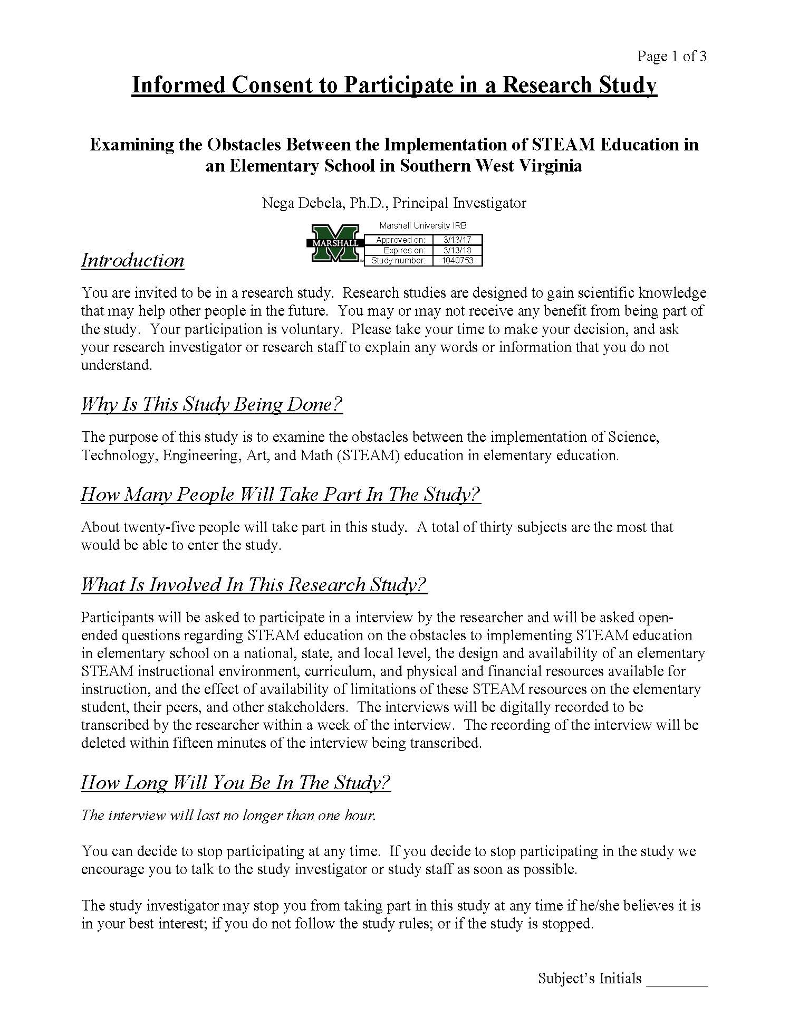

Appendix C: Cover Design for the 2017 Doctoral Seminar Booklet

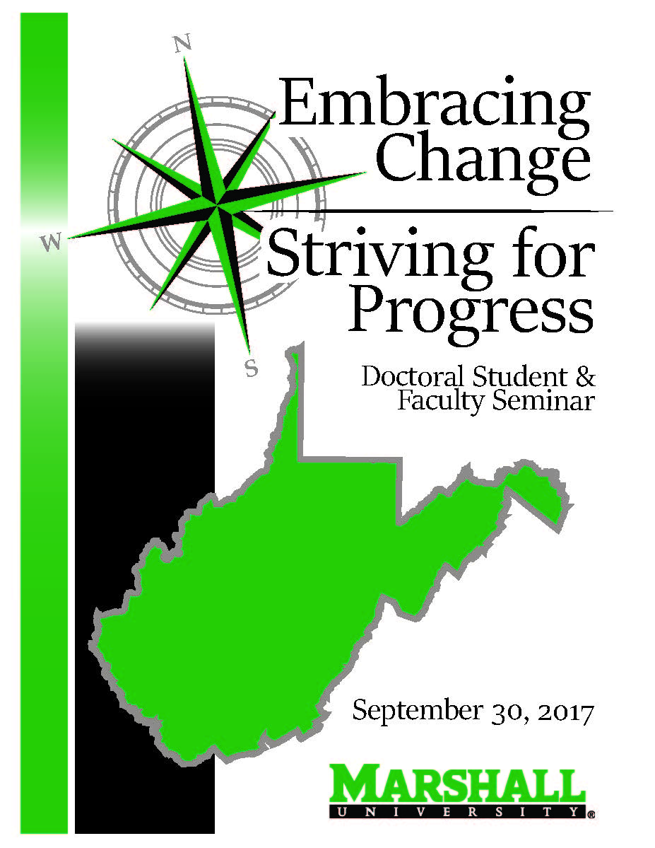
Appendix D: Planning Committee Documentation for 2017 Doctoral Seminar Booklet Page

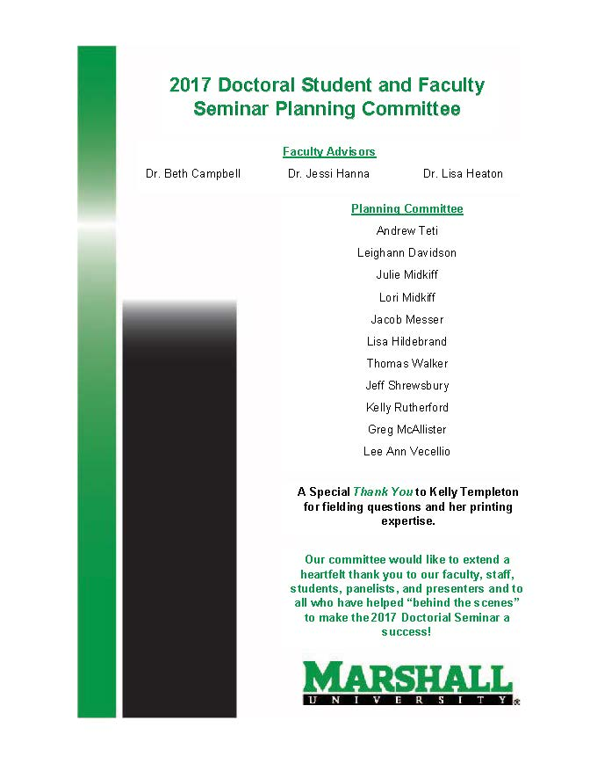
Appendix E: CI 701 Curricular Theory Paper
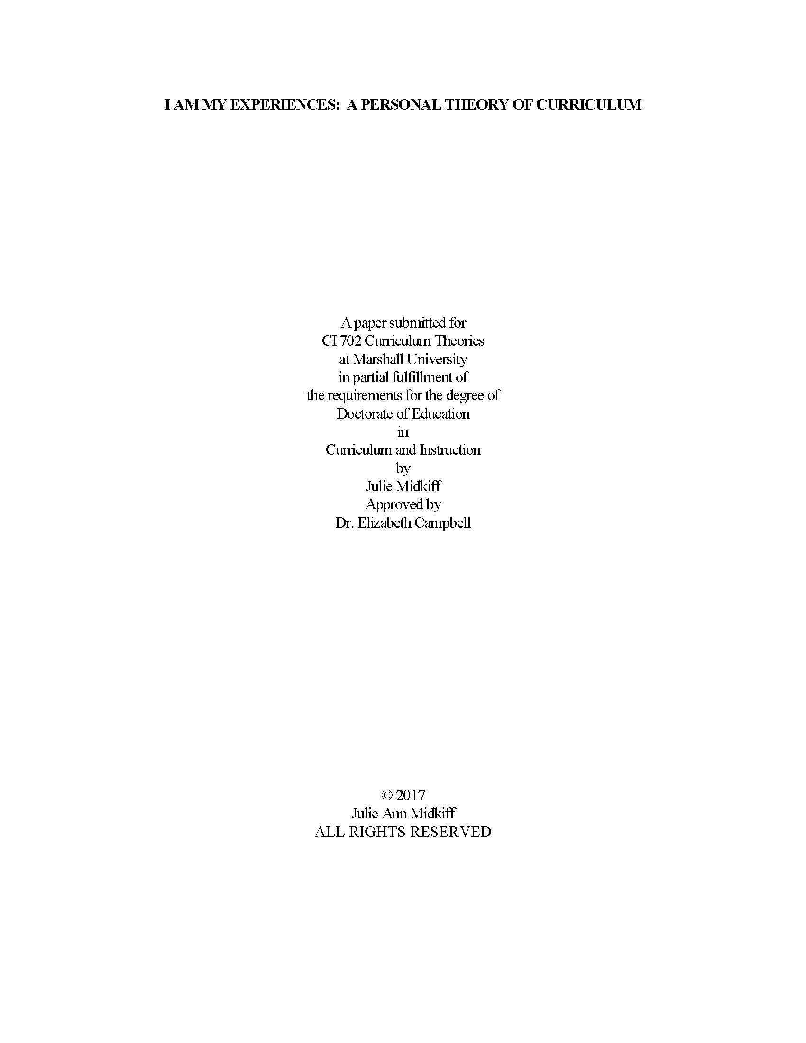
Appendix F: CI 701 Curricular Theory Paper Introduction
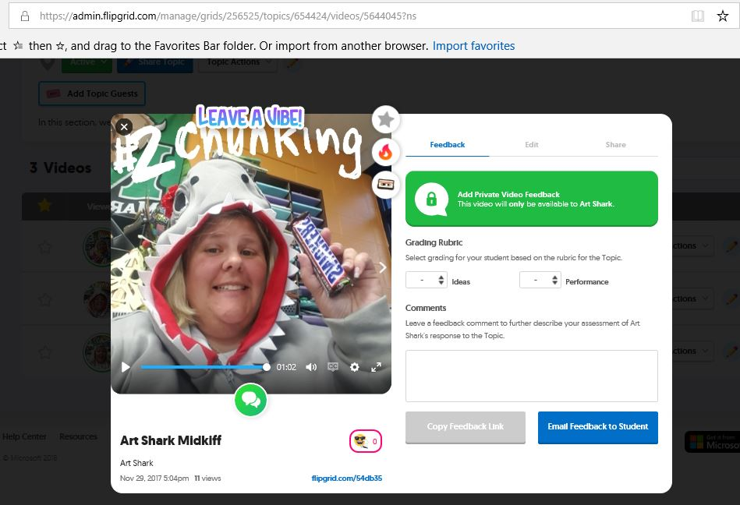
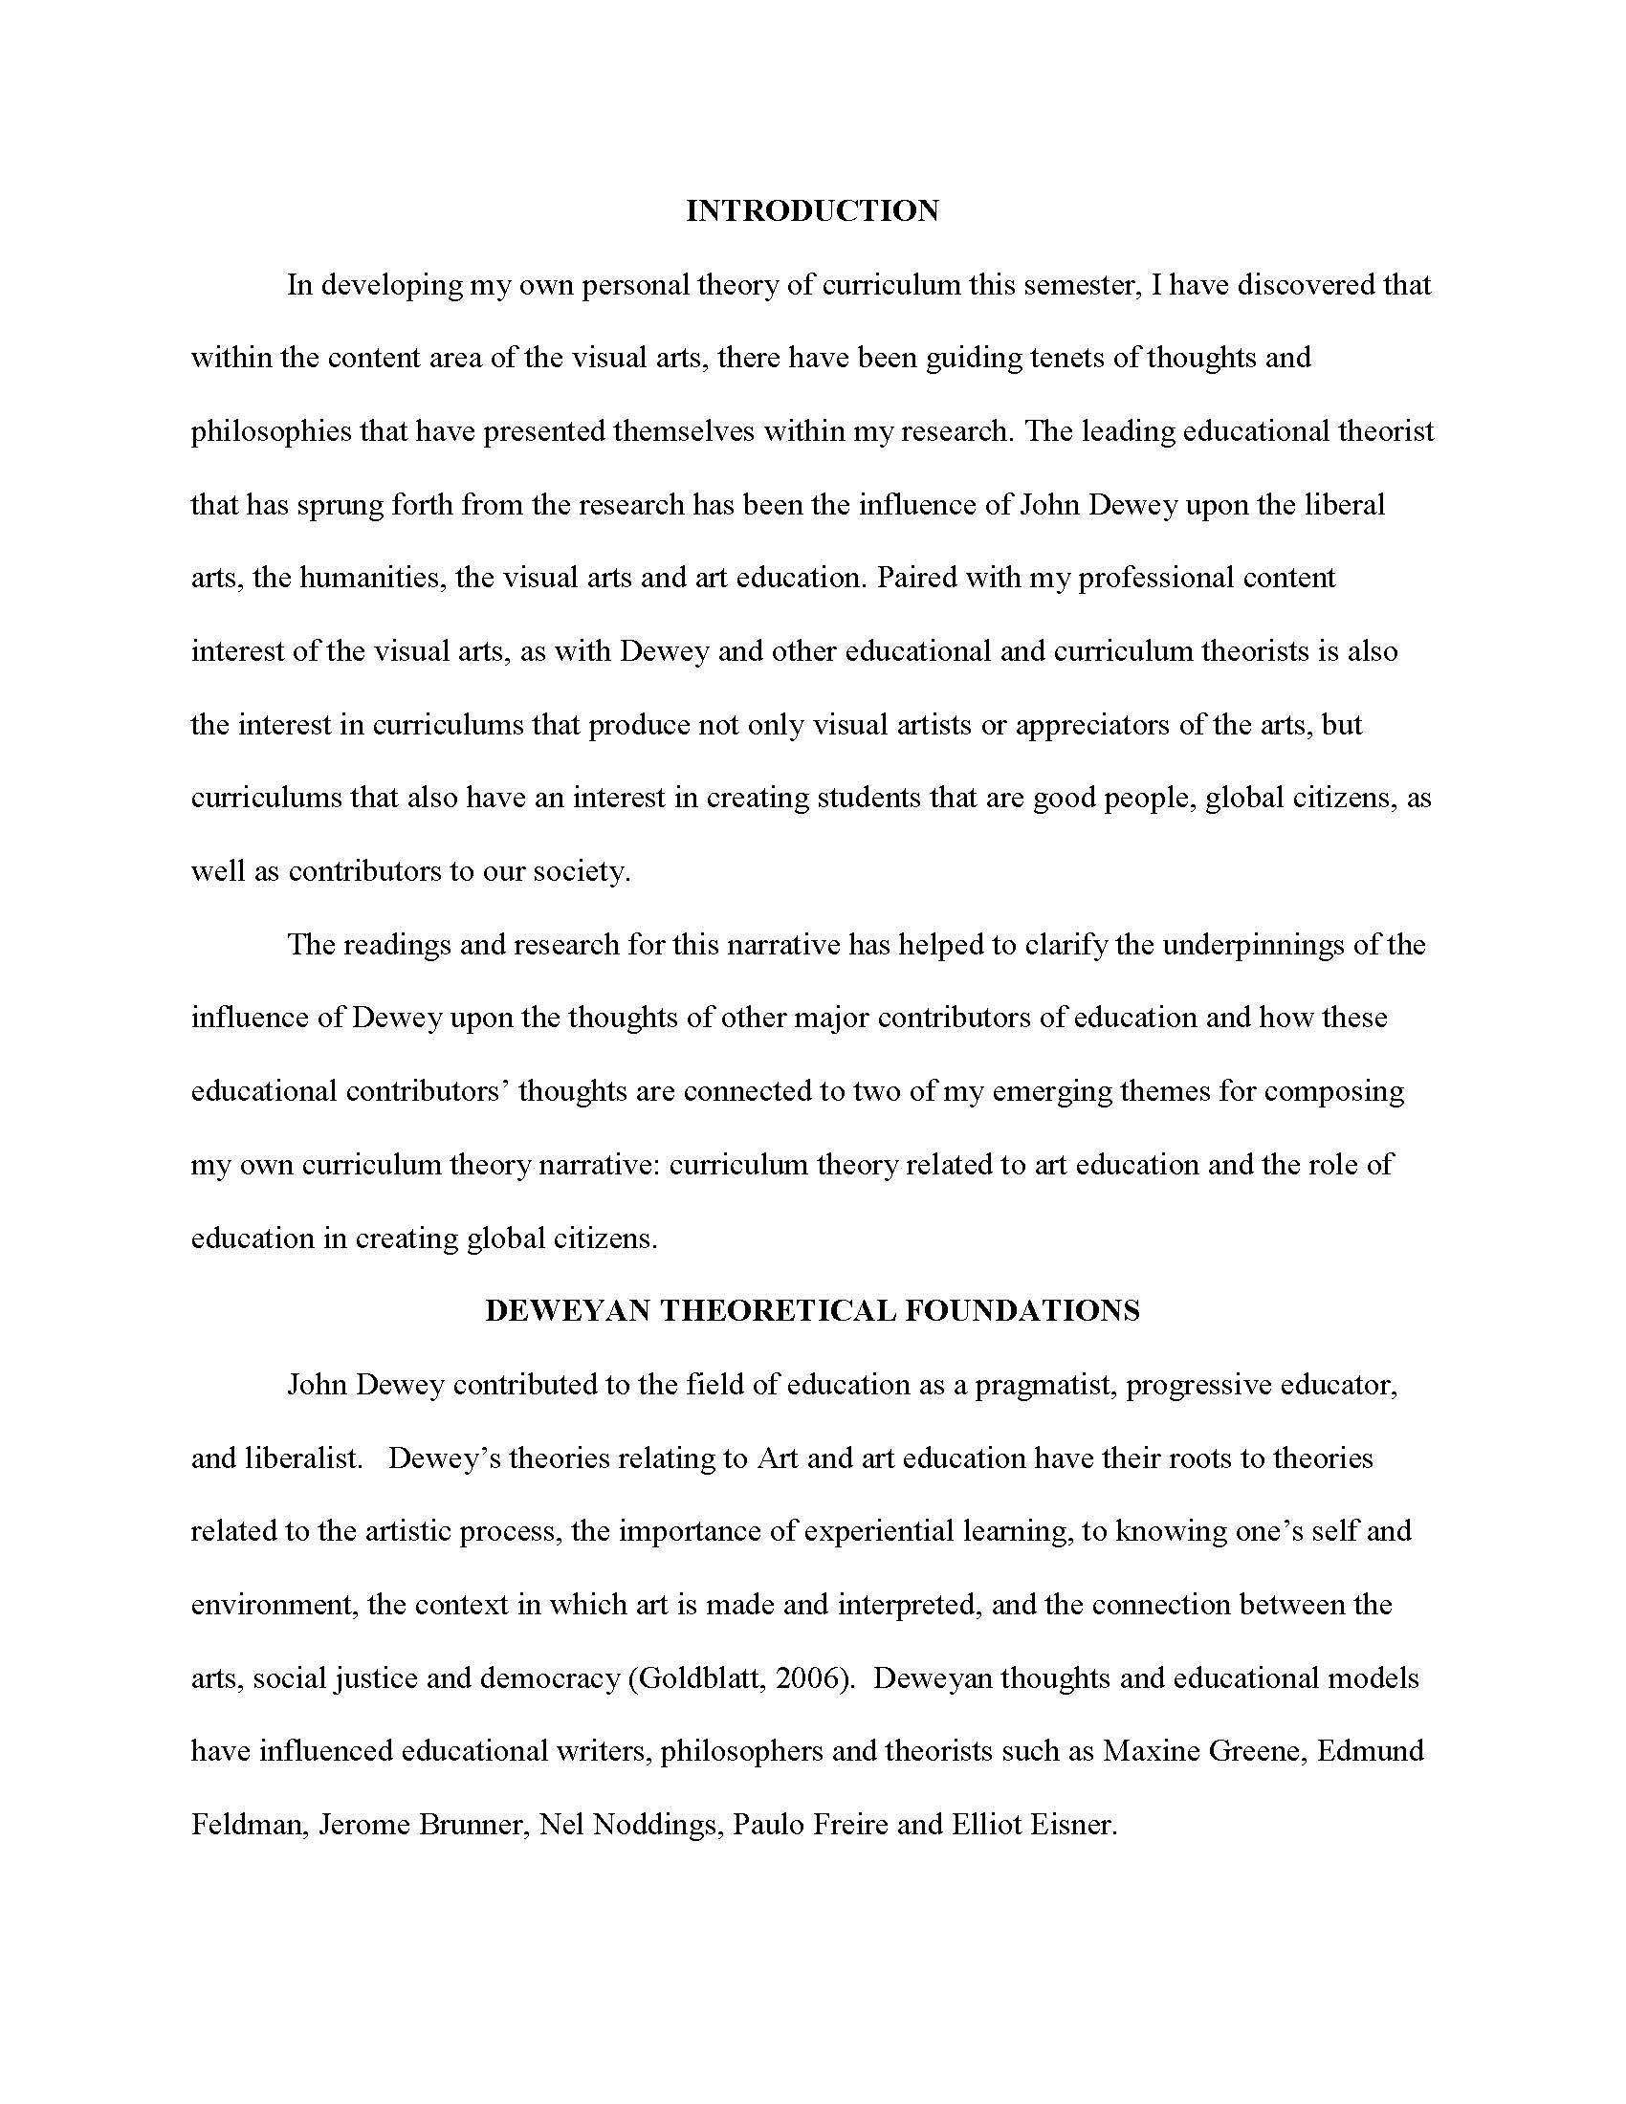
Appendix G: CIEC 700: Technology and Curriculum FlipGrid Development
Appendix H: Infographic of Tiger Tools for Student Digital Product Creation
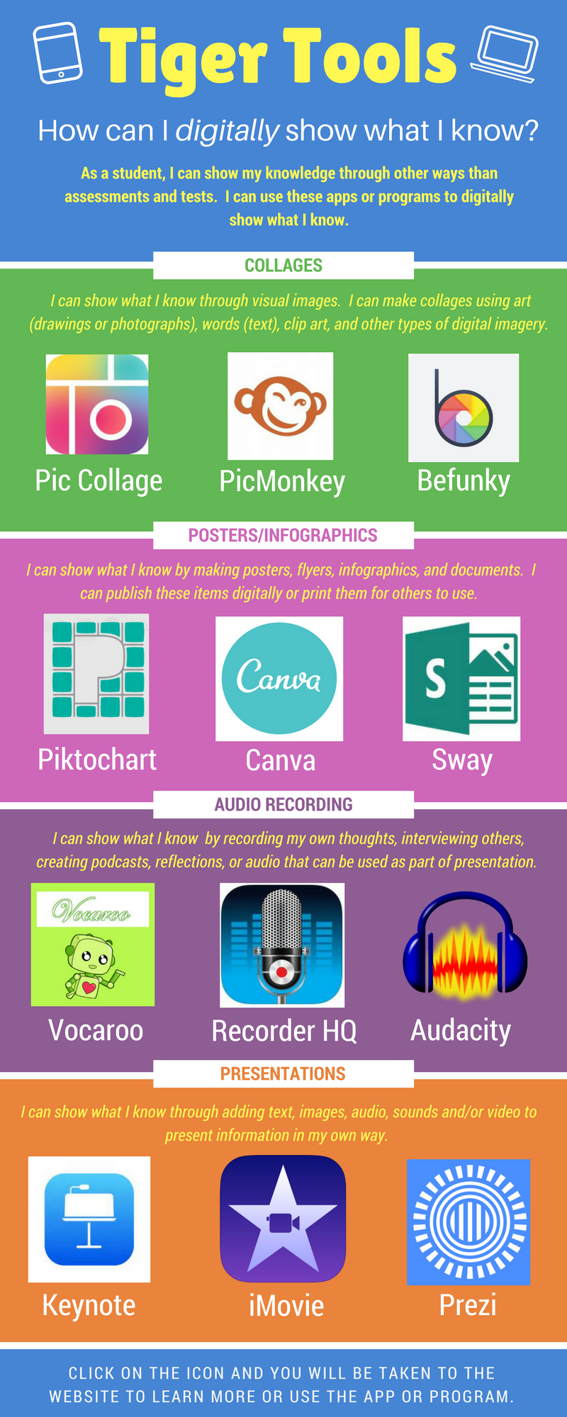
Infographic Created using Canva.
www.canva.com

Appendix I: Infographic of Tiger Tools for Teacher Digital Product Creation and Integration
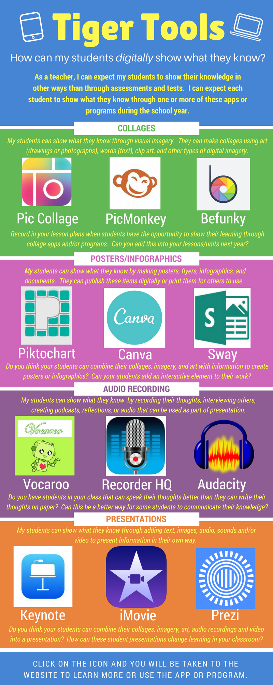
Infographic Created using Canva.
www.canva.com

Appendix J: EDF 725 Advanced Qualitative Methods Elk River Chemical Spill Mini Ethnography

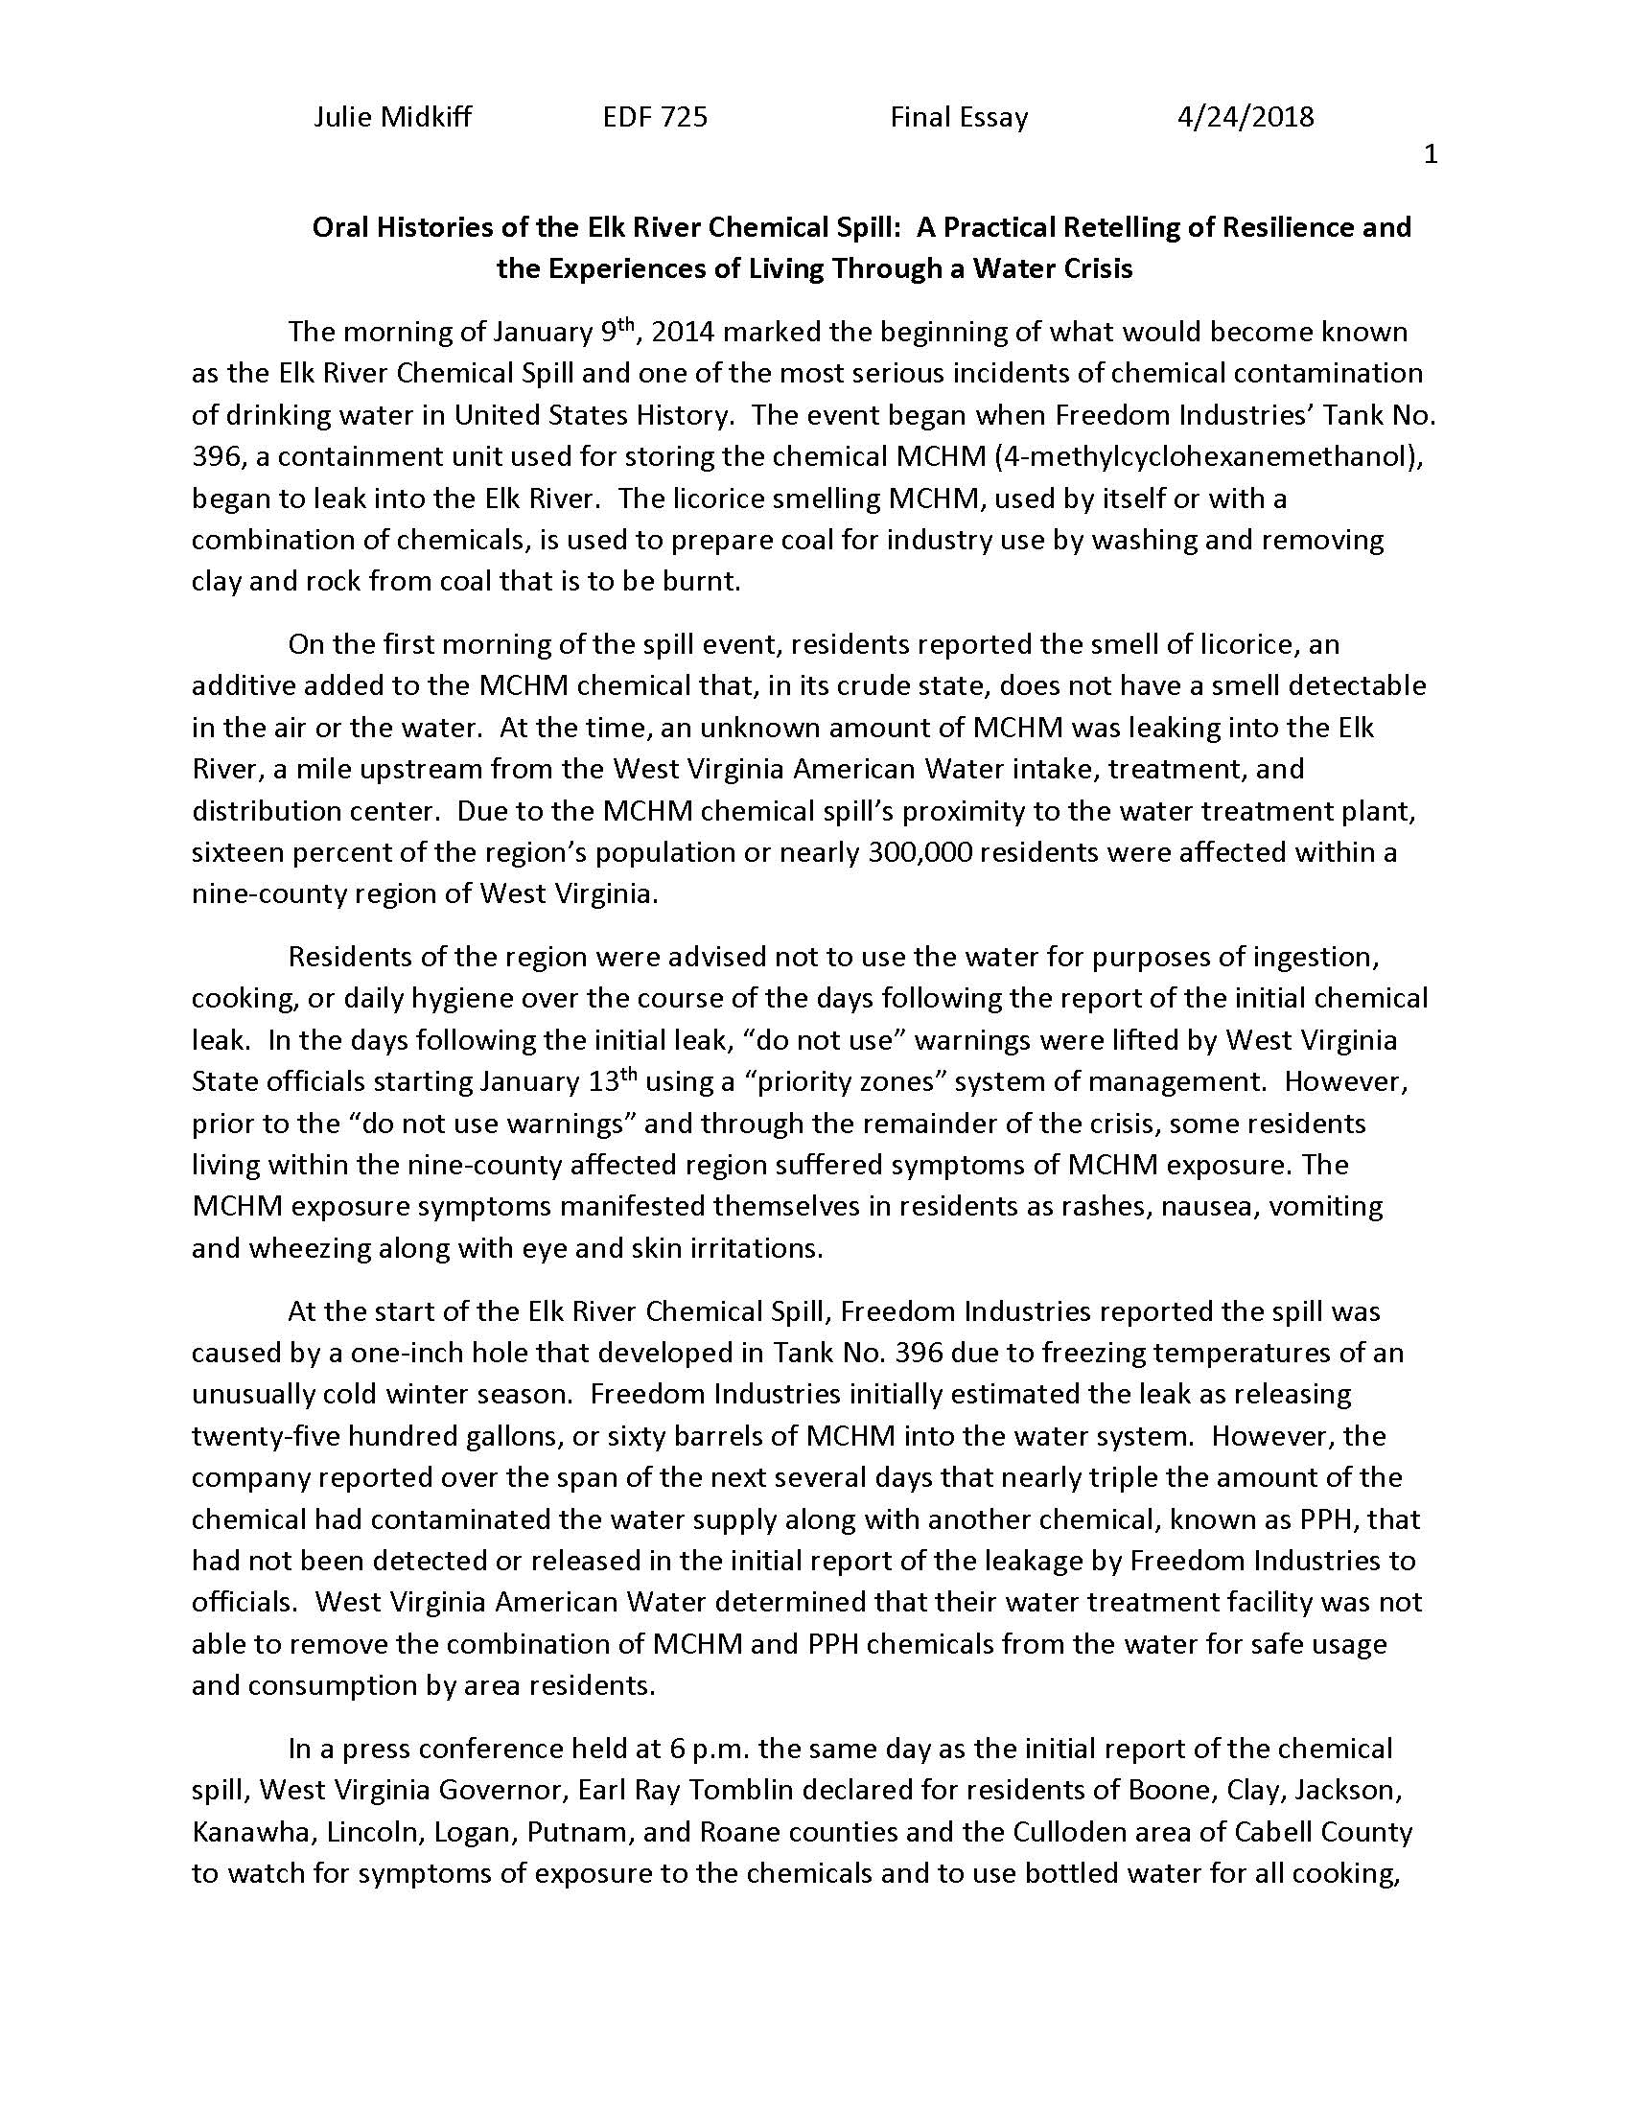
Appendix K: Co-Presenter at the 2018 Appalachian Studies

Association Conference (WebPage Evidence)
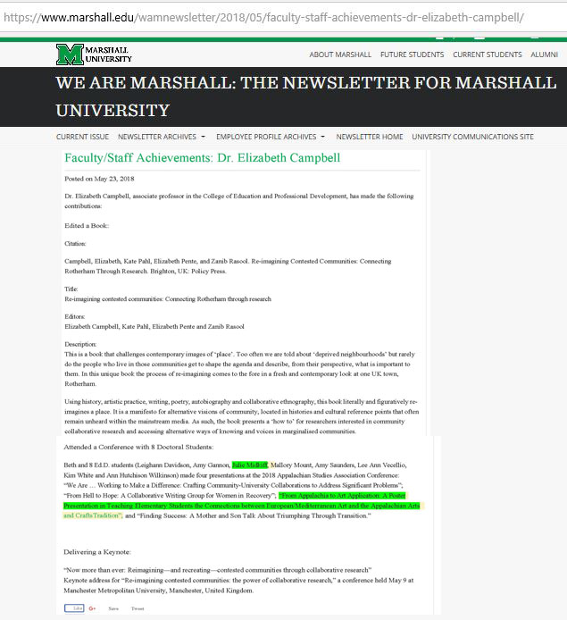
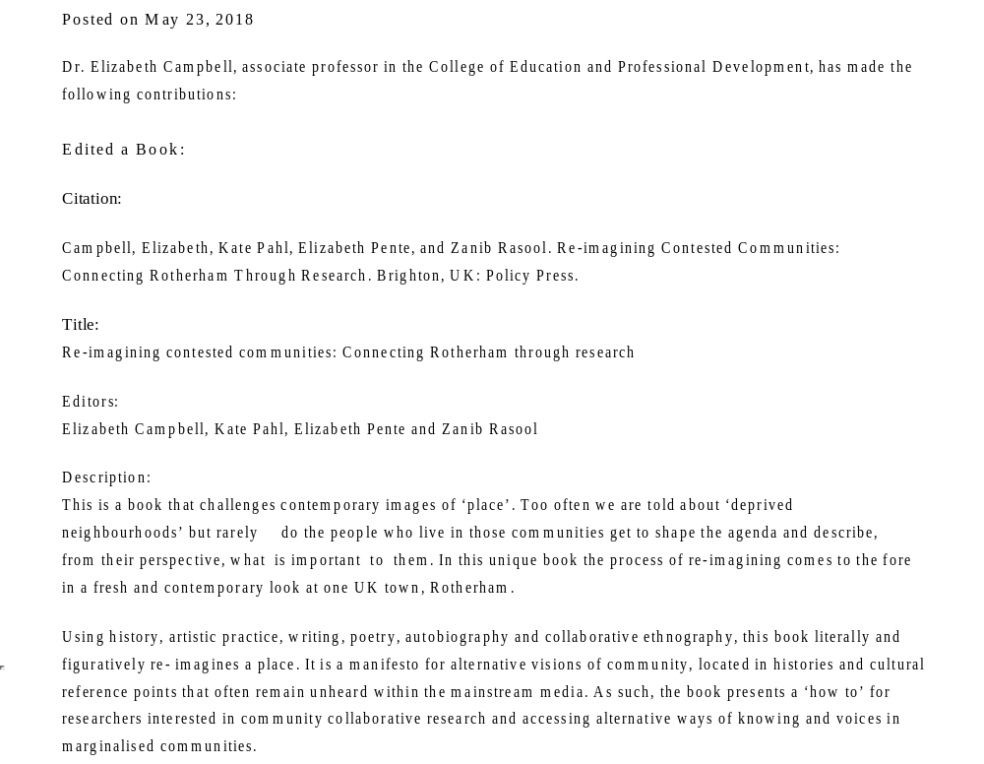
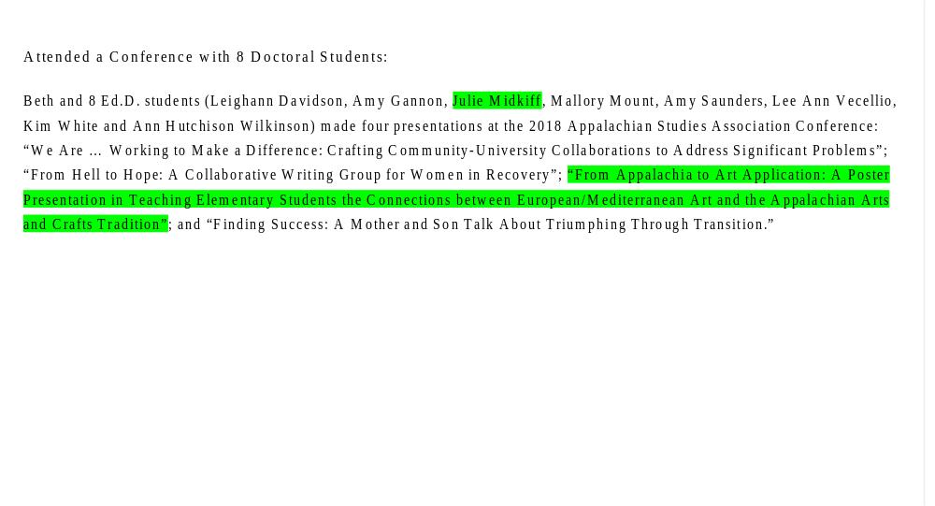

Appendix L: Co-Presenter at the 2018 Appalachian Studies

Association Conference (Photo Collage Evidence)
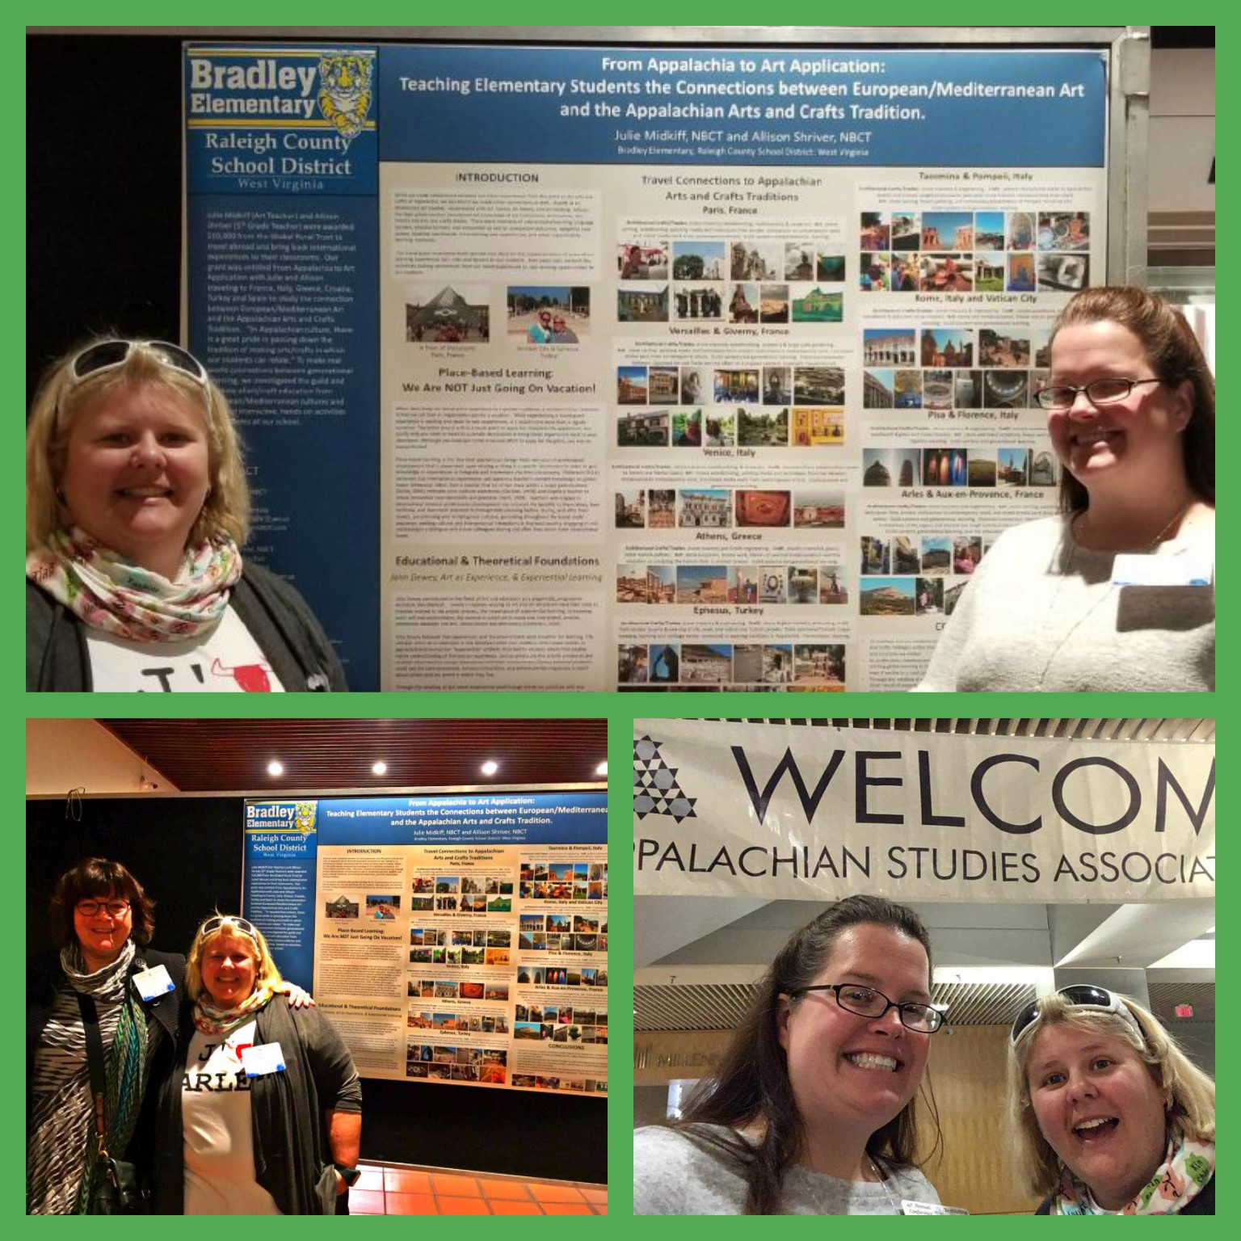

Photo collage created with the application Befunky

Appendix M: Co-Presenter at the 2018 Southeastern Association of Vertebrate Palentology

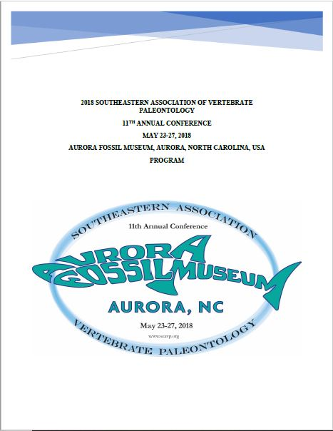
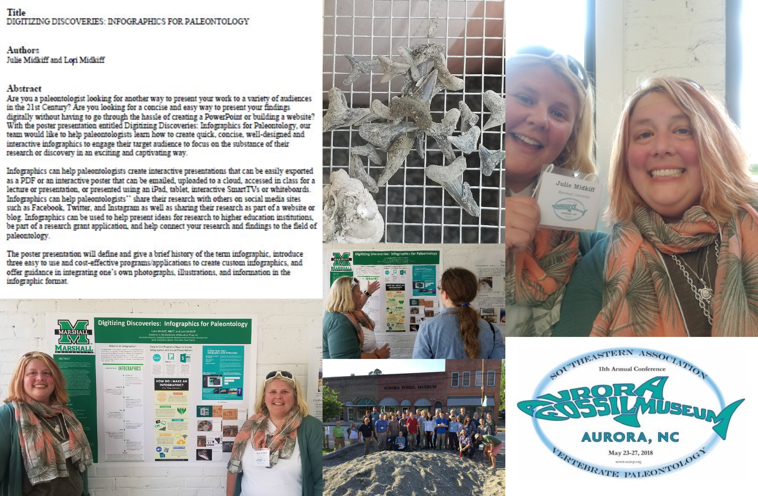
Appendix N: Co-Presenter at the Southeastern Association of Vertebrate Palentology (PHOTO COLLAGE EVIDENCE)

Photo collage created with the web version of Befunky

Appendix O: Summer 2018 Co-Teaching with Dr. Lassiter in EDF 625 (Qualitative Research in Education)
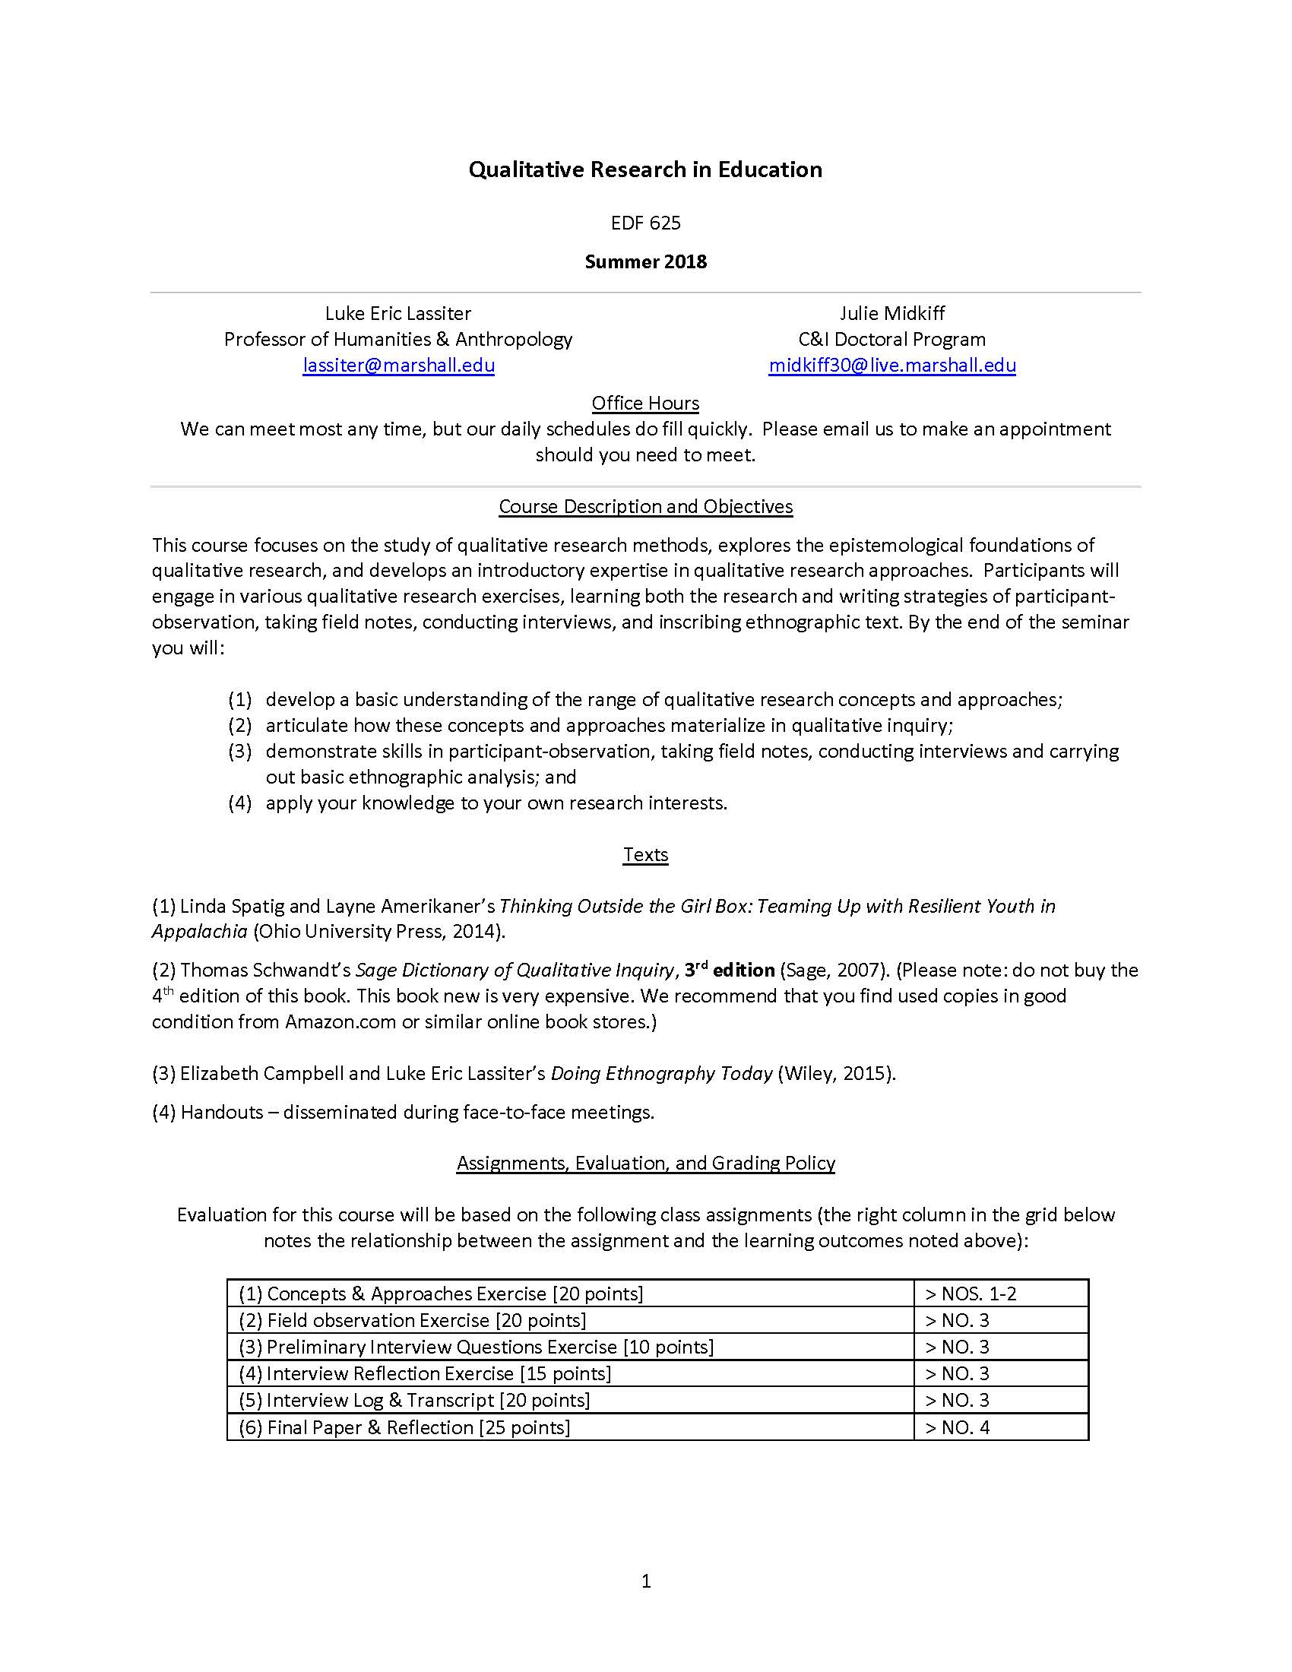
Appendix P: CULS 600 “Autoethnography on a Page” (Front Side)
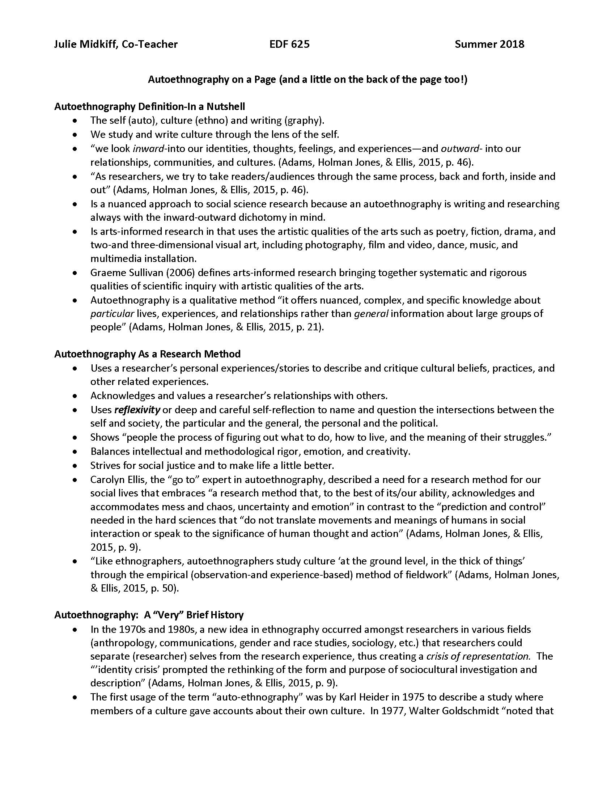

Appendix Q: CULS 600 “Autoethnography on a Page” (Back Side)
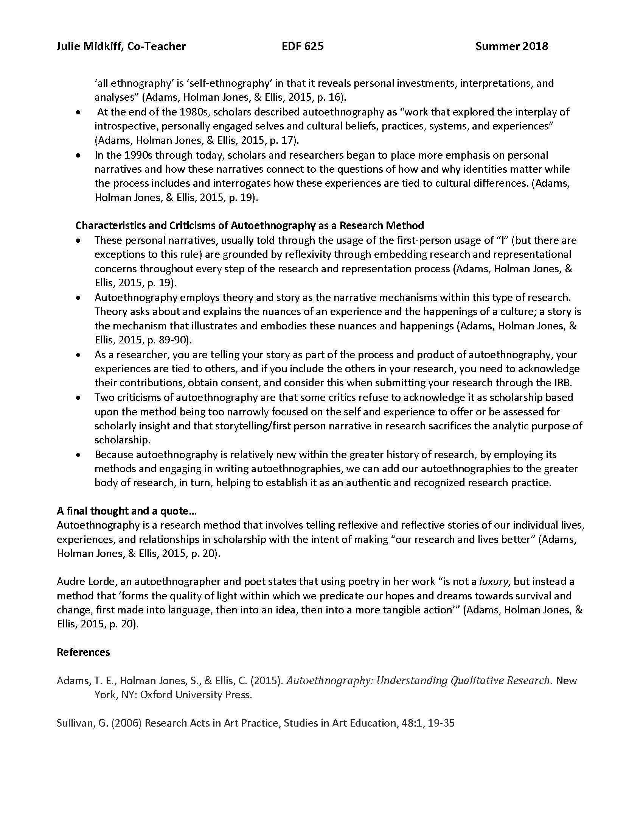

Appendix R: Cover design for the 2018 Doctoral Seminar Booklet
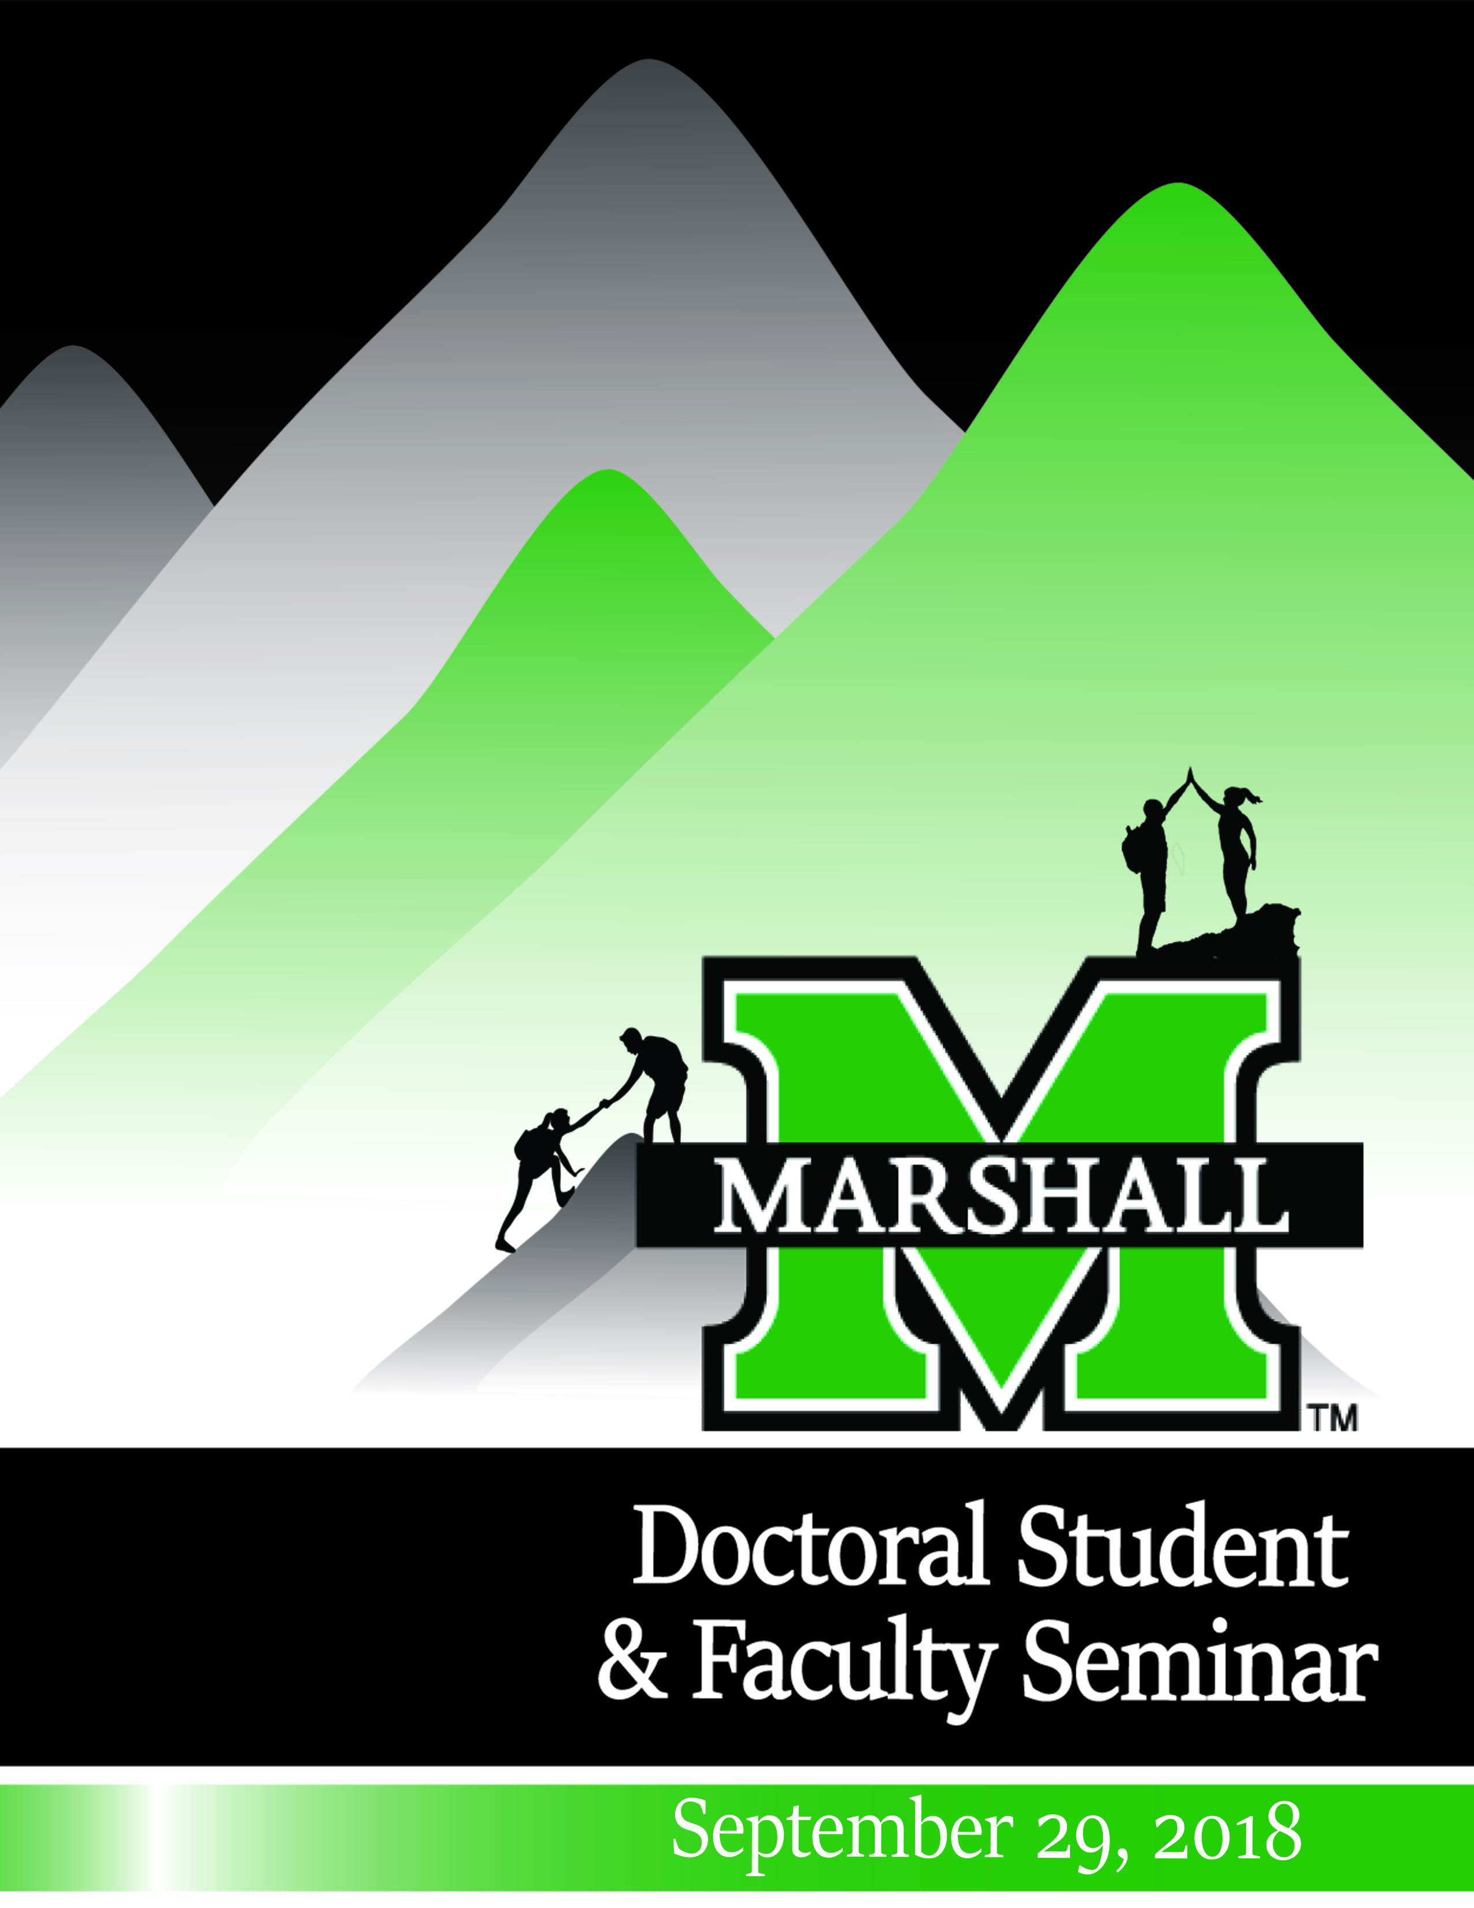

Appendix s: Planning Committee Documentation for 2018 Doctoral Seminar Booklet Page
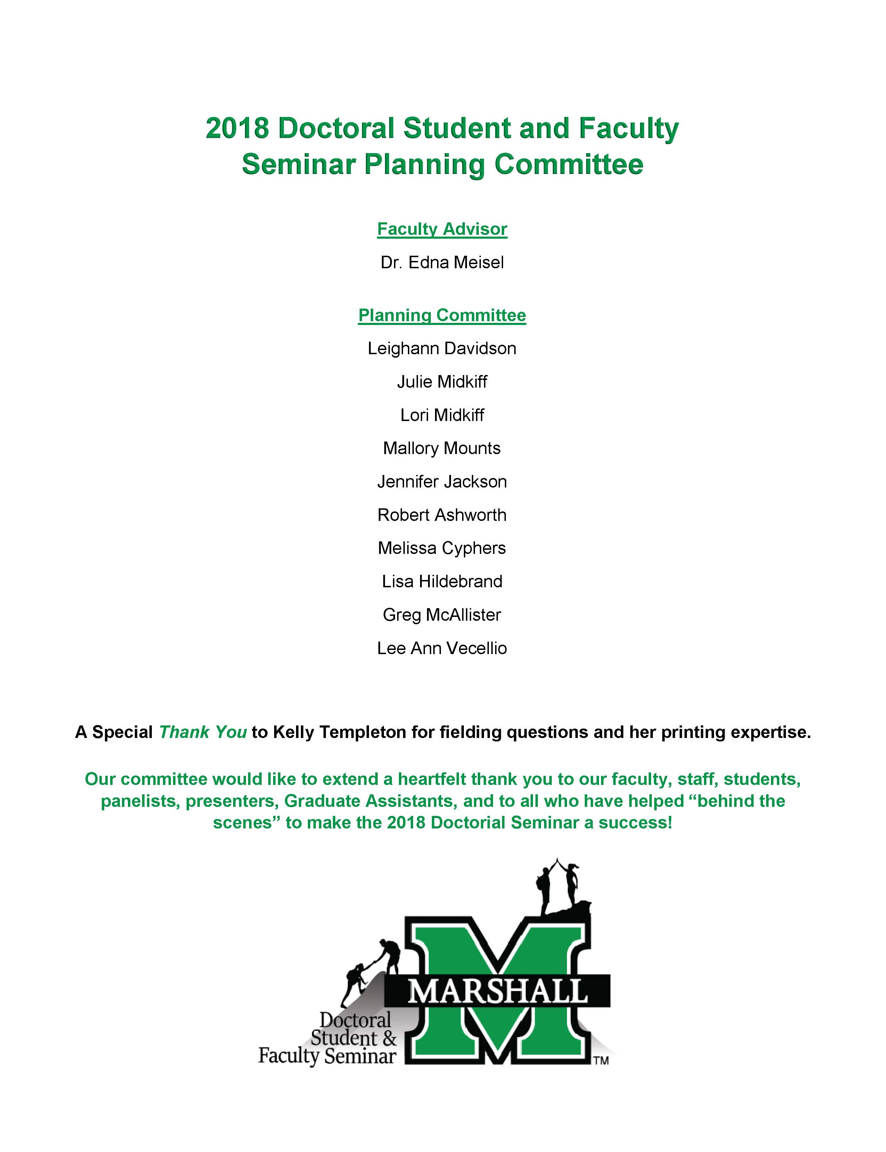

Appendix t: 2018 NEA Foundation Global Fellows Book Publication (Cover)
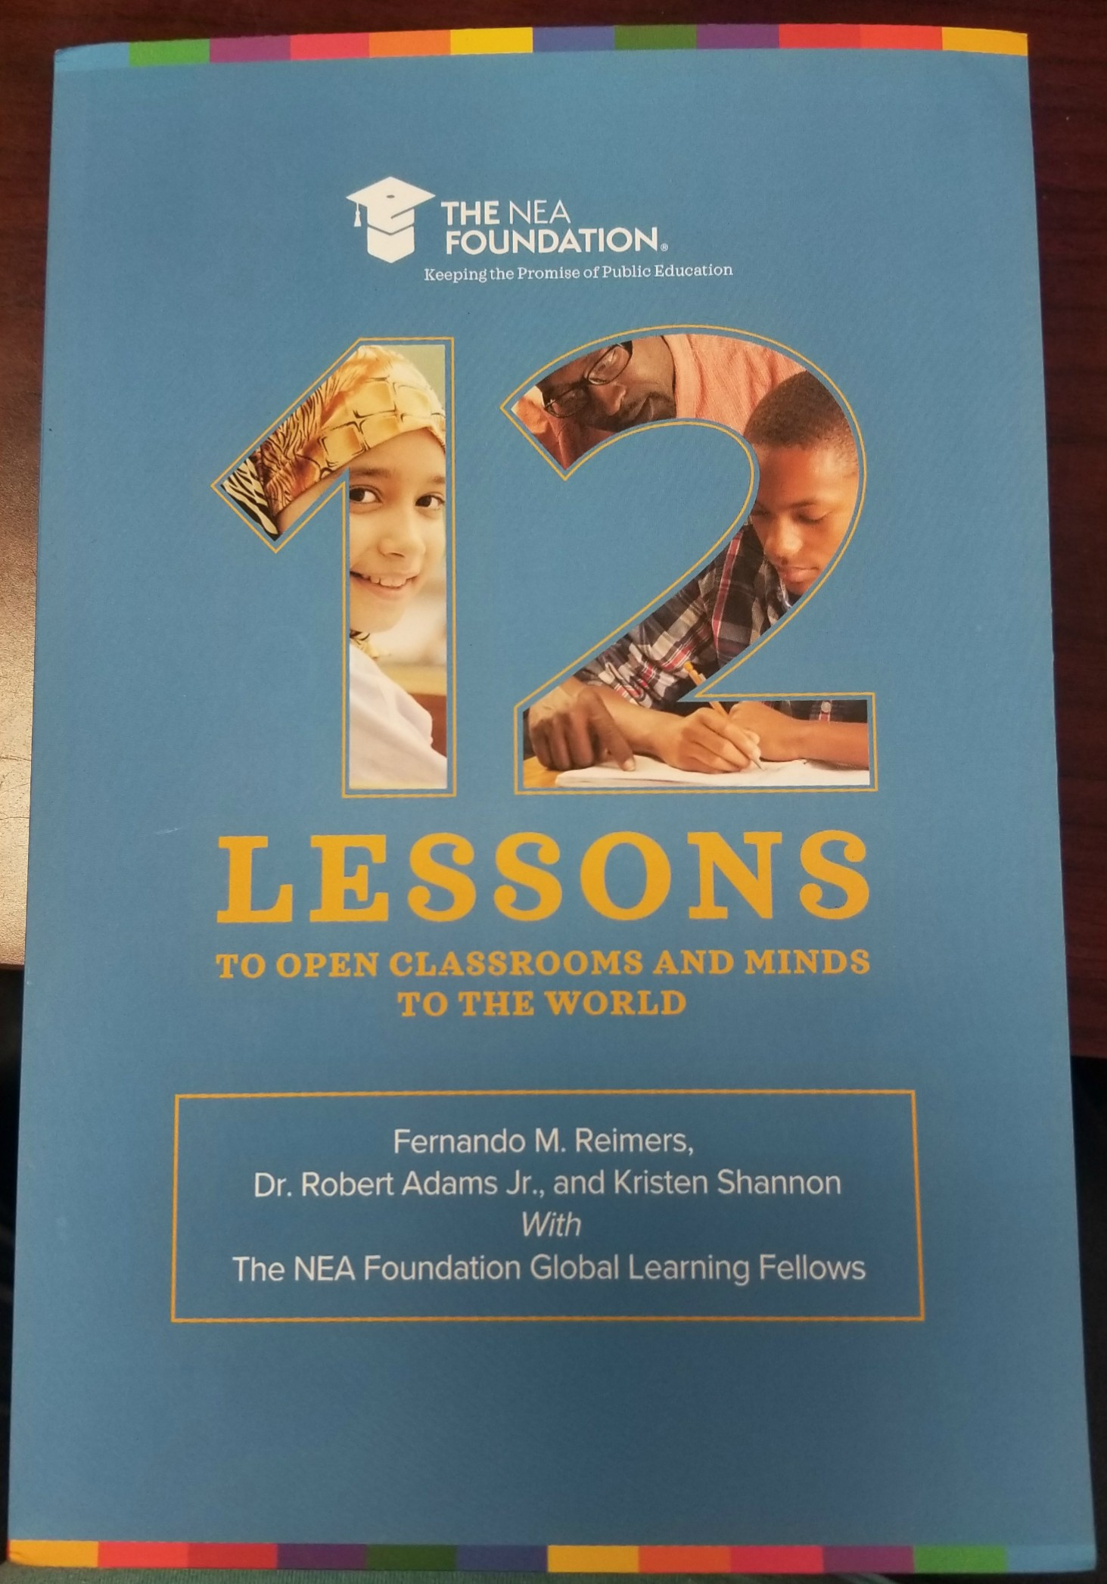

Appendix u: 2018 NEA Foundation Global Fellows Book Publication (Kindergarten Lesson Plan)
